COUNCIL REPORT

 | Panel Reference | PP2-2019EC1028
 | DA Number | BD.2018.125
 | LGA | Burwood
 | Proposed Development | Concept Development Application for the amalgamation of 9 lots to create 1 lot, retention of the existing Burwood Uniting Church and associated school hall building, construct 3 new buildings consisting of Building 1 – a 26 storey mixed-use building containing, commercial uses on the lower levels, and a residential apartment with 124 apartments, Building 2 – a 5 storey mixed use building containing retail uses at ground level and student housing (boarding house) on the upper levels, and Building 3 – a 1.5 storey building containing Church gathering and administration offices, the adaptive reuse of the school hall building to a restaurant, basement level car parking over 5 levels, associated site landscaping and a site access/through link
 | Street Address | 134A-134C Burwood Road, and 29A-33A George Street, Burwood
 | Applicant/Owner | The Uniting Church Property Trust (NSW) – applicant and owner
 | Date of DA lodgement | 2 November 2018
 | Number of Submissions | Six (6)
 | Recommendation | Approved, Subject to Conditions
 | Regional Development Criteria (Schedule 7 of the SEPP (State and Regional Development) 2011 | Cost of development exceeding $30million  Proposed cost of development $107,946,300.00
 | List of all relevant 4.15(1)(a) matters | - State Environmental Planning Policy (Building Sustainability Index: BASIX) 2004  - Sydney Regional Environmental Plan (Sydney Harbour Catchment) 2005  - State Environmental Planning Policy (Affordable Rental Housing) 2009  - State Environmental Planning Policy (Vegetation in Non-Rural Areas) 2017  - State Environmental Planning Policy (Educational Establishments and Childcare Facilities) 2017  - State Environmental Planning Policy No. 55 – Remediation of Land  - State Environmental Planning Policy No. 65 – Design Quality of Residential Apartment Development  - Burwood Local Environmental Plan (LEP) 2012  - Burwood Development Control Plan (DCP) 2013  - The likely social, environmental and economic impacts of the development  - The suitability of the site for the development  - The Public Interest  - Submissions made under the Act and Regulations
 | List all documents submitted with this report for the Panel’s consideration | - Architectural Plans: ISSUE J:DA-100-001; DA-100-002; DA-110-001; DA-110-002; DA-110-003; DA-110-004; DA-110-005; DA-110-006; DA-110-007; DA-110-008; DA-110-009; DA-110-010; DA-110-011; DA-110-012; DA-110-013; DA-110-014; DA-110-015; DA-110-016; DA-250-001; DA-250-003; DA-250-003; DA-350-001; DA-350-002; DA-350-003; DA-350-004; DA-350-005; DA-710-001; DA-710-002; DA-710-003; DA-710-004; DA-710-005; DA-710-006; DA-710-007; DA-710-008; DA-820-001; DA-820-002; DA-820-003; DA-820-004; DA-820-005; DA-820-006; DA-820-007; DA-820-008; DA-820-009; DA-820-010; DA-820-101; DA-820-102. Prepared by TURNER dated 14 August 2020;  - Survey Plans – Revision F, prepared by TURNER dated 18 October 2018  - Architectural Design Report – Issue J, prepared by TURNER dated 14 August 2020;  - Streetview Analysis Burwood Road, Drawing Set, prepared by TURNER dated 14 August 2020;  - Supplementary Statement of Heritage Impact prepared by GBA Heritage dated 13 August 2020;  - Statement of Environmental Effects; Amended Application Statement ; Clause 4.6 Submission; ADG Assessment, prepared by URBIS dated October 2081 and 17 August 2020;  - Schedule of Conservation Works/Amended, prepared by GBA Heritage dated July 2019;  - Landscape Concept Report, prepared by Place Design Group, dated August 2019;  - Traffic and Parking Impact Assessment – Issue E, prepared by TTPA dated February 2020.
 | Report prepared by | Emma Buttress-Grove, Senior Town Planner - Building and Development
 | Report date | 15 September 2020
Summary of s4.15 matters  Have all recommendations in relation to relevant s4.15 matters been summarised in the Executive Summary of the assessment report? |  |  | Yes
Legislative clauses requiring consent authority satisfaction  Have relevant clauses in all applicable environmental planning instruments where the consent authority must be satisfied about a particular matter been listed, and relevant recommendations summarized, in the Executive Summary of the assessment report?  e.g. Clause 7 of SEPP 55 - Remediation of Land, Clause 4.6(4) of the relevant LEP |  |  | Yes
Clause 4.6 Exceptions to development standards  If a written request for a contravention to a development standard (clause 4.6 of the LEP) has been received, has it been attached to the assessment report? |  |  | Yes
Special Infrastructure Contributions  Does the DA require Special Infrastructure Contributions conditions (S94EF)?  Note: Certain DAs in the Western Sydney Growth Areas Special Contributions Area may require specific Special Infrastructure Contributions (SIC) conditions |  |  | No
Conditions  Have draft conditions been provided to the applicant for comment?  Note: in order to reduce delays in determinations, the Panel prefer that draft conditions, notwithstanding Council’s recommendation, be provided to the applicant to enable any comments to be considered as part of the assessment report |  |  | Yes

(PP2-2019EC1028) DA.2018.125 – Concept Development Application for the amalgamation of 9 lots to create 1 lot, retention of the existing Burwood Uniting Church and associated school hall building, construct 3 new buildings consisting of Building 1 – a 26 storey mixed-use building containing, commercial uses on the lower levels, and a residential apartment with 124 apartments, Building 2 – a 5 storey mixed use building containing retail uses at ground level and student housing (boarding house) on the upper levels, and Building 3 – a 1.5 storey building containing Church gathering and administration offices, the adaptive reuse of the school hall building to a restaurant, basement level car parking over 5 levels, associated site landscaping and a site access/through link.

REPORT BY: Senior Town Planner

Owner: The Uniting Church Property Trust (NSW)
Applicant: The Uniting Church Property Trust (NSW)
Location: 134A-134C Burwood Road, and 29A-33A George Street, Burwood
Zoning: B4 Mixed Use

Proposal
The Concept Development Application being for the amalgamation of 9 lots to create 1 lot, retention of the existing Burwood Uniting Church and associated school hall building, construct 3 new buildings consisting of Building 1 – a 26 storey mixed-use building containing, commercial uses on the lower levels, and a residential apartment with 124 apartments, Building 2 – a 5 storey mixed use building containing retail uses at ground level and student housing (boarding house) on the upper levels, and Building 3 – a 1.5 storey building containing Church gathering and administration offices, the adaptive reuse of the school hall building to a restaurant, basement level car parking over 5 levels, associated site landscaping and a site access/through link.

Regional Planning Panel Referral Criteria
The application is referred to the Regional Planning Panel as the proposal has a capital investment value over $30 million.

Locality

Subject Site
The subject site is an “L” shaped allotment with a 40m frontage to Burwood Road and a 40m frontage to George Street. The site currently contains the Uniting Church (heritage item) associated Sunday School Hall (heritage item), a commercial building fronting Burwood Road, and 2 x pairs of semi-detached dwellings and a detached dwelling on George Street (see Images 1-6 below).

The site has a combined area of 5,028sq.m and comprises nine (9) existing lots contained within the Burwood Town Centre and is legally described in the following table:

Lot No. | DP No. | Address
1  M | 795259  409157 | 134A Burwood Road, Burwood
N | 409157 | 134C Burwood Road, Burwood
A | 306236 | 134B Burwood Road, Burwood
10 | 669145 | 29A/B George Street, Burwood
2 | 102050 | 31A George Street, Burwood
1 | 102050 | 31B George Street, Burwood
2 | 511068 | 33A George Street, Burwood
1 | 511068 | 33A George Street Burwood

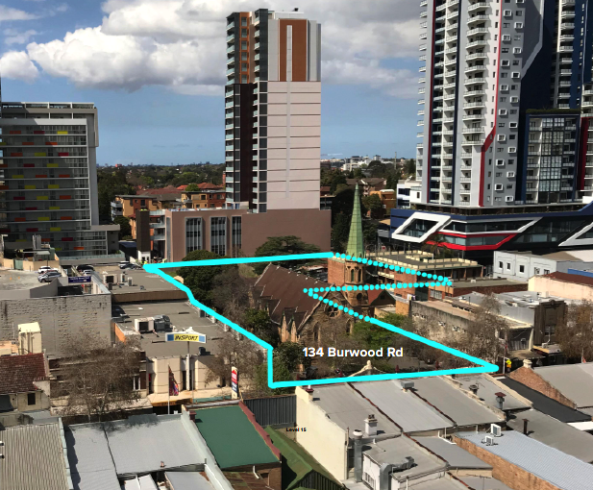
Image 1: Site Aerial. Courtesy: TURNER
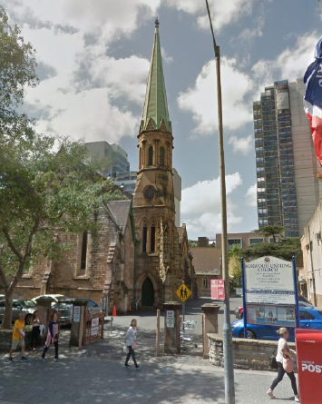
Image 2: Burwood Uniting Church. Courtesy: Google Maps

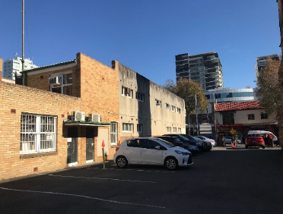
Image 3: Car Park and commercial building (134C Burwood Road). Courtesy: Google Maps

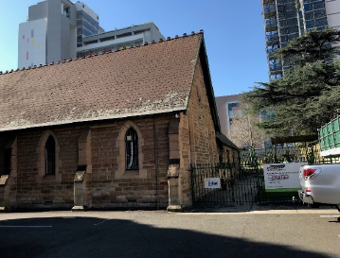
Image 4: School Church Hall. Courtesy: Google Maps

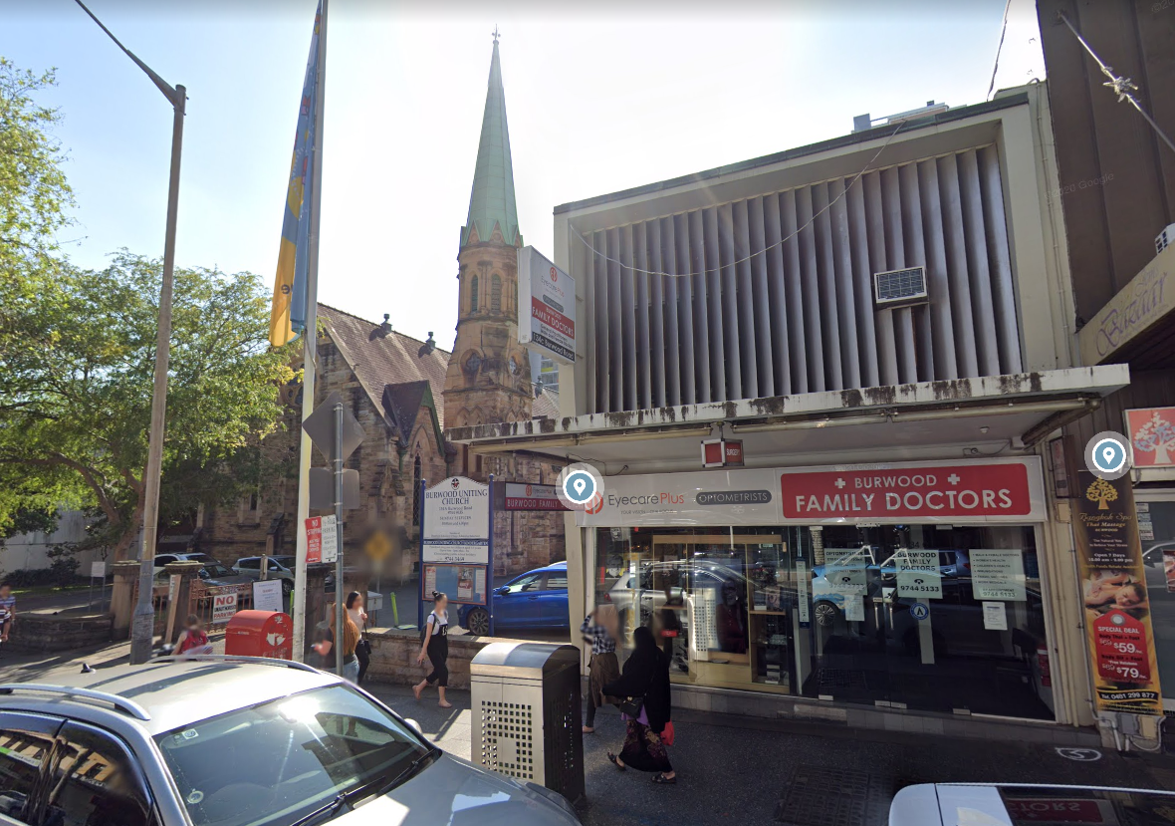
Image 5:Uniting Church (left) 134C Burwood Road (right). Courtesy: Google Maps

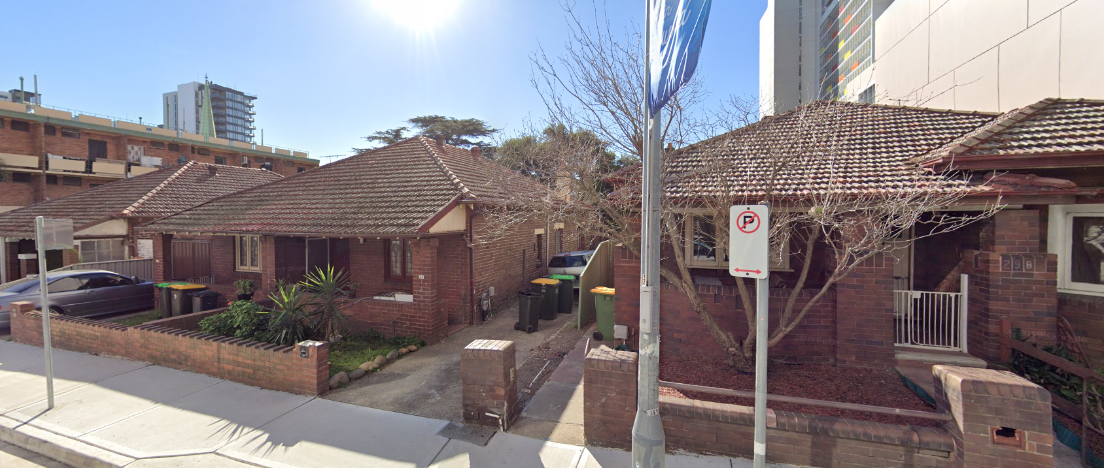
Image 6: No’s 33A & 33B (far left), No. 31B & 31 (middle) & No. 29B (right) George Street, Burwood.
Courtesy: Google Maps

Surrounding Development
Surrounding development is a mixture of commercial, residential and mixed use development, characteristic of the sites location within Burwood Town Centre. A description of surrounding development is as follows:

North
To the north of the site is No. 132-134 Burwood Road, Burwood which contains a two-storey commercial building (refer Image 7 below).

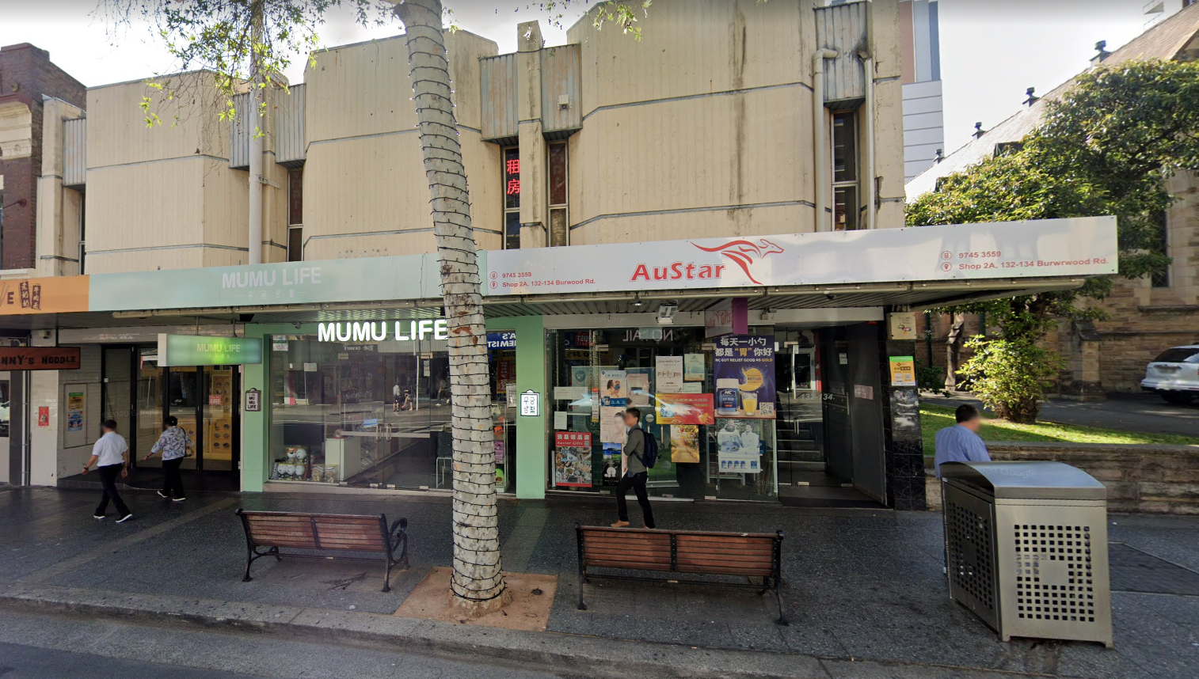
Image 7: No.’s 132-134 Burwood Road, Burwood. Courtesy: Google Maps

South
To the south of the site along Burwood Road is a group of 2 two-storey commercial buildings being No.’s 136-142 Burwood Road, Burwood. Also to the south of the site is a 3 storey residential flat building known as 31-35 George Street, Burwood (see Images 8 & 9 below).

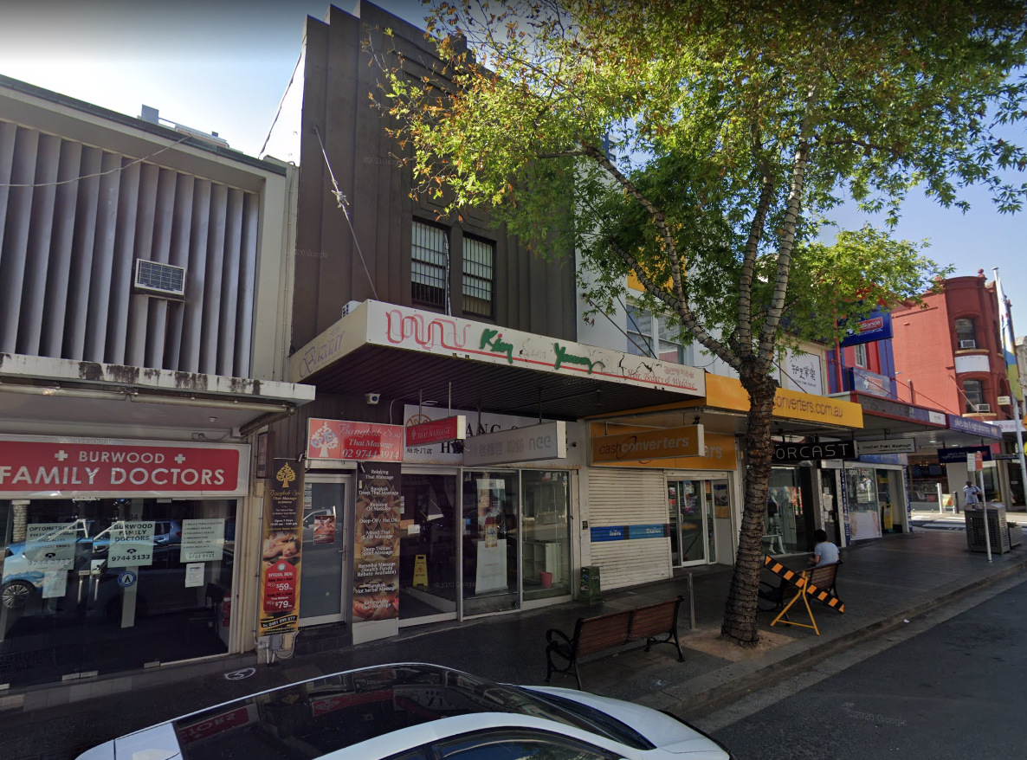
Image 8:No.s 136-142 Burwood Road, Burwood. Courtesy: Google Maps

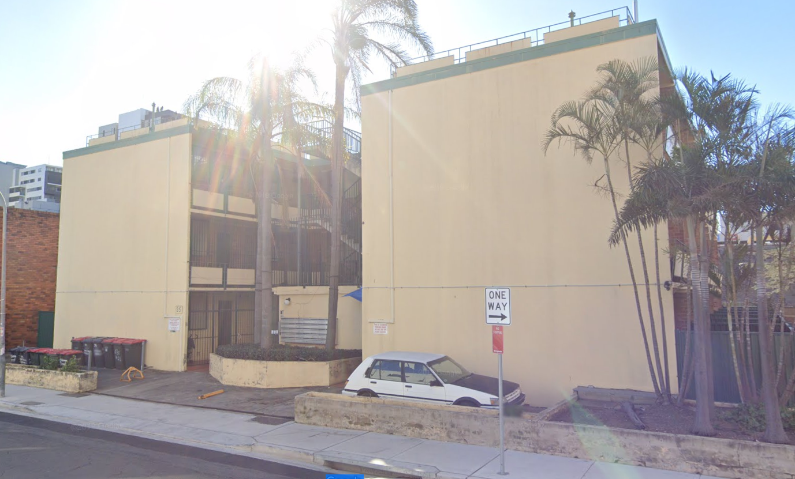
Image 9: No. 31-35 Burwood Road, Burwood. Courtesy: Google Maps

East
To the east (rear) of the site is the adjoining property known as No. 29 George Street which has recently been redeveloped to facilitate a 19-storeymixed-use development, and to the south-east opposite George Street is a high rise mixed development commercial/residential known as 2 Mary Street, Burwood (see Image 10 below).

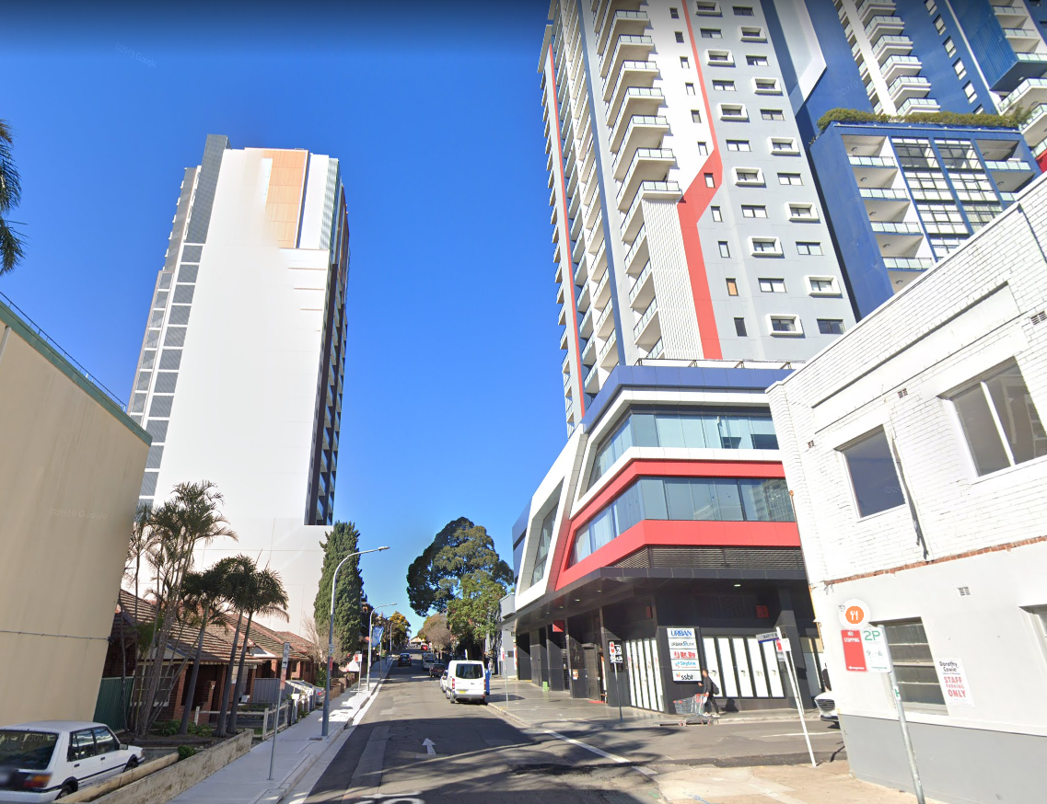
Image 10: No. 29 George Street (left) & No 2 Mary Street Burwood. Courtesy: Google Maps

West
To the west of the site immediately opposite Burwood Road, are a group of two storey commercial buildings known as No.’s 77-91 Burwood Road, Burwood (see Image 11 below).

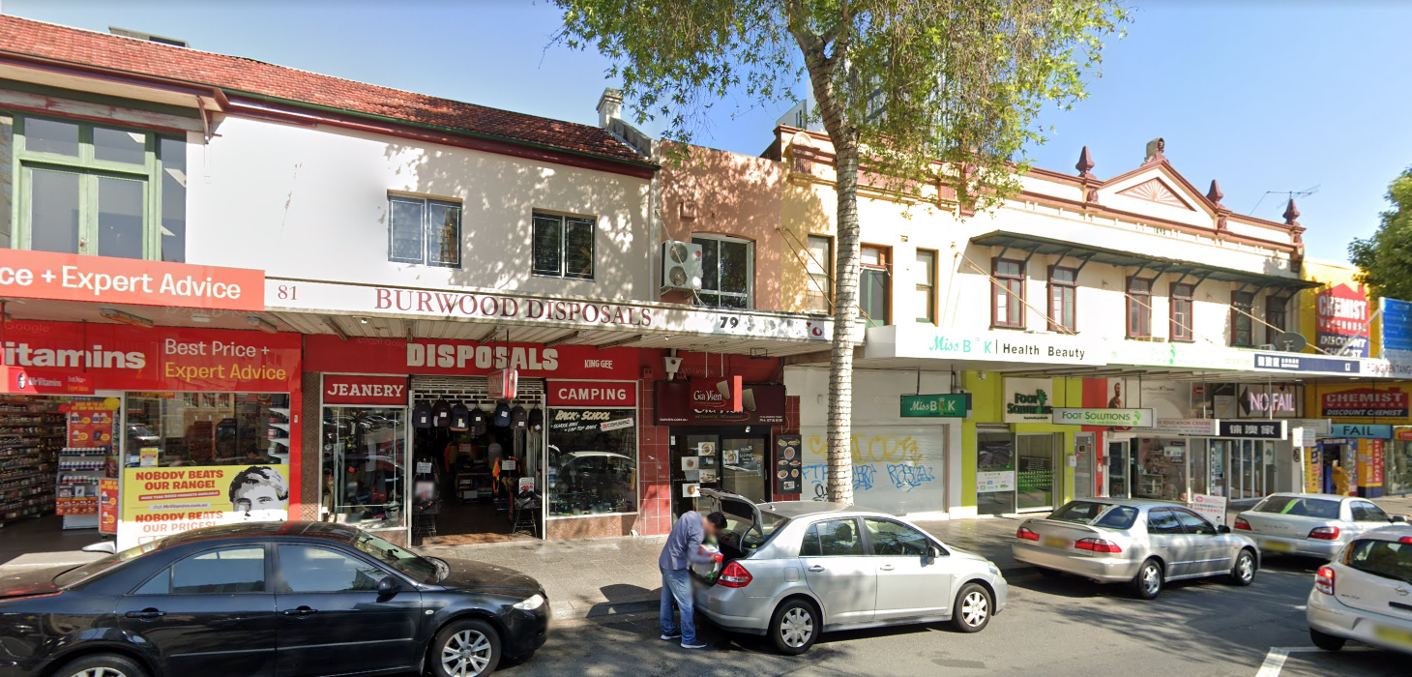
Image 11: No’s 91 (far left) to No. 77 (far right) Burwood Road, Burwood. Courtesy: Google Maps

DESCRIPTION OF DEVELOPMENT
The amended Concept Development Application for the amalgamation of 9 lots to create 1 lot, retention of the existing Burwood Uniting Church and associated school hall building, construct 3 new buildings consisting of Building 1 – a 26 storey mixed-use building containing, commercial uses on the lower levels, and a residential apartment with 124 apartments, Building 2 – a 5 storey mixed use building containing retail uses at ground level and student housing (boarding house) on the upper levels, and Building 3 – a 1.5 storey building containing Church gathering and administration offices, the adaptive reuse of the school hall building to a restaurant, basement level car parking over 5 levels, associated site landscaping and a site access/through link.

The specifics of the Concept Development Application are provided below:

- Site Amalgamation
  - Amalgamation of 9 sites into 1 site;
- Burwood Uniting Church
  - Retention of the existing Burwood Uniting Church for its continued use as a place of public worship with conservation works to facilitate its preservation and ongoing use;
- School/Church Hall
  - Retention of the existing School/Church Hall and adaptive re-use as a “food and drinks” premises with training and employment opportunities associated with church outreach programmes and community activities;
- Demolition
  - Demolition of existing 2 storey commercial building at No. 134C Burwood Road;
  - Demolition of the existing semi -detached dwellings at No. 33A & B George Street, demolition of the semi-detached dwellings at 31A & B George Street, and demolition of the detached dwelling at 29 George Street, Burwood;
- Building 1 – Mixed Use Tower Building
  - New building at the rear of the site fronting George Street containing:
  - Basement car parking over 5 levels under the main tower building.
  - Ground level: Church offices, childcare centre/church entrance lobby, retail tenancy, garbage rooms and loading bay, lifts, fire access/services and vehicular entrances to basement level car parking.
  - Upper ground level: Church offices, retail tenancy fronting George Street, entrance to residential lobby mail room, and commercial lobby from George Street, plant room, fire access/services and vehicular entrance to basement level car parking.
  - Level 1: Childcare centre (1065sq.m) and outdoor play area (724sq.m) lifts, fire access/services;
  - Level 2: Medical Centre (1380.50sq.m), lifts and fire access/services;
  - Level 3: Commercial Office (1236.4sq.m), lifts and fire access/services;
Residential Flat Building Component Levels 4-24
  - Level 4: 10 x apartments, consisting of 7 x 2 bedroom (including 3 cross-over apartments) and 3 x 1 bedroom, lifts, and fire access/services;
  - Level 5: 6 x apartments, consisting of 4 x 2 bedroom and 2 x 1 bedroom, lifts, and fire access/services (and other half of Level 4 2 x bedroom cross-over apartments);
  - Level 6: 10 x apartments consisting of 7 x 2 bedroom (including 3 cross-over apartments) and 3 x 1 bedroom, lifts, and fire access/services;
  - Level 7: 9 x apartments consisting of 7 x 2 bedroom and 2 x 1 bedroom, lifts, and fire access/services (and other half of Level 4 2 x bedroom cross-over apartments);
  - Level 8: 4 residential apartments consisting of 3 x 2 bedroom and 1 x 1-bedroom, Communal Open Space area (452sq.m), lifts and fire access/services;
  - Level 9: 4 x residential apartments consisting of 3 x 2 bedroom, and 1 x 1 bedroom, lifts, and fire access/services;
  - Levels 10-21: 6 x residential apartments consisting of 5 x 2 bedroom and 1 x 3 bedroom, lifts, and fire access/services, on each level;
  - Levels 22-24: 4 residential apartments consisting of 3 x 2 bedroom and 1 x 1 bedroom, lifts, and fire access/services, on each level;
  - Level 25: roof level containing plant room, lifts, fire access/services and stairs, and outdoor deck area.
- Building 2 – Mixed Use Commercial/Student Accommodation (boarding house)
  - Construction of a new 5 storey building between Church and southern boundary containing:
  - Ground level: Restaurant/retail tenancies, fire stairs and toilets;
  - Upper ground level: Student accommodation (boarding house) containing 64 rooms and common room, lift and fire access/services;
  - Level 1: Student accommodation, lift and fire access/services;
  - Level 2: Student accommodation, lift and fire access/services;
  - Level 3: Student accommodation, lift and fire access/services;
  - Level 4: Student accommodation, lifts, and fire access/service.
- Building 3 – Church Gathering and Administration Building
  - Construction of new church administration/gathering building between northern boundary and existing Church containing a gathering area, toilets, kitchen and meeting rooms. Basement level and void above ground level;
- Through site link
  - A Through site link is proposed from Burwood Road, behind the Church through the new building at the rear exiting out the northern end of the site with pedestrian access to Victoria Street East;
- Gross Floor Area:
  - Total floorspace of 19,833sqm gross floor area (GFA) comprising both existing and new buildings and accommodating a range of land use activities, including:
  - Building 1
    - Retail: 128sq.m
    - Child care centre: 1,307sq.m
    - Commercial Offices: 1,372sq.m
    - Residential Apartments: 12,269sq.m
  - Building 2
    - Retail/Restaurants: 605sq.m
    - Student Accommodation: 1,530sq.m
  - Building 3
    - Ancillary Offices: 1,207sq.m
  - Church 282sq.m
  - School/Church Hall
    - Restaurant 300sq.m
- Building Heights
  - Building 1 (Tower/George Street) – 26 storeys, 91.5m above n.g.l;
  - Building 2 (south/Burwood Road) – 5 storeys, 24.9m above.n.g.l
  - Building 3 (north/Burwood Road) – 1-2 storeys, 5.33m above n.g.l

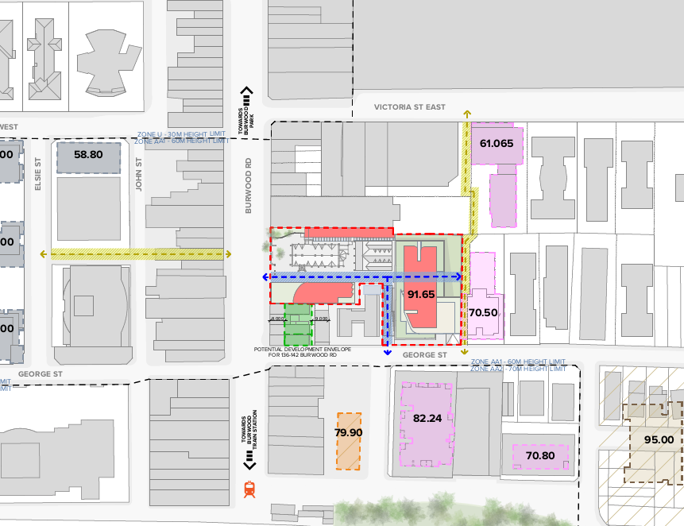
Image 2:Indicative Site Plan. Courtesy: TURNER

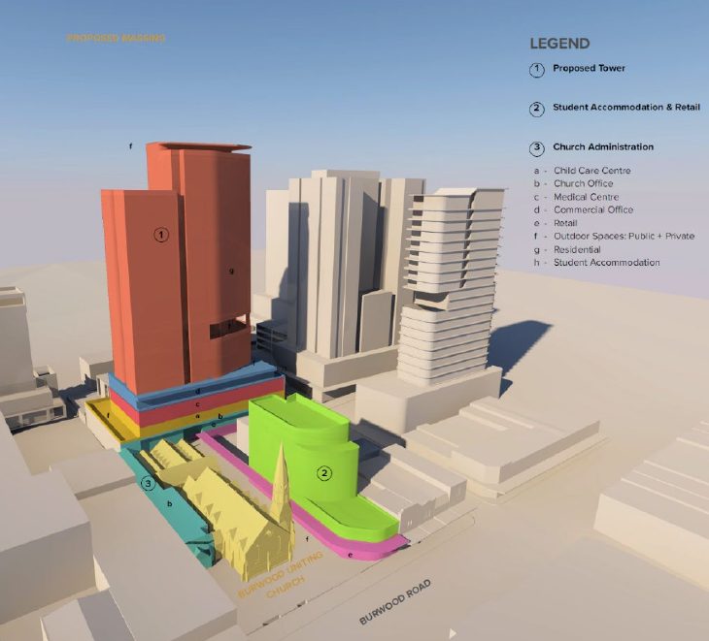
Image 3: Proposed Massing. Courtesy: TURNER

APPLICATION HISTORY
The Concept Development Application was lodged with Council on 2 November 2018. A history of the application is as follows:

- The application underwent public exhibition from 22 November until 17 December 2018, six (6) submissions were received in response.
- The application was referred to the following internal Council departments:
  - Landscaping;
  - Traffic;
  - Environmental Health;
  - Building;
  - Heritage;
- The application was referred to GMU Urban Design consultants on 22 November 2018;
- A request for additional information letter was sent to the Applicant on 28 November 2018 requesting an updated Landscape Plan.
- A request for additional information email was sent to the Applicant on 6 December 2018 requesting the submission of a Public Art Plan (PAP) in accordance with the Public Art Strategy.
- A request for additional information letter was sent to the Applicant on 25 February 2019 requesting the submission of a Clause 4.6 submission, a PAP, GMU comments and traffic matters;
- A request for additional information email was sent to the Applicant on 4 April 2019 containing the heritage assessment issues;
- On 16 August 2019 additional information was submitted to Council by the Applicant;
- On 13 October 2019, the amended plans and documentation were re-referred to GMU Urban Design Consultants;
- A request for additional information email was sent to the Applicant on 4 December 2019 in relation to traffic and heritage referral issues;
- On 29 January 2020 a meeting was held between the Applicant and Council to discuss outstanding matters relating to the application;
- On 11 March 2020 additional information was submitted to Council by the Applicant;
- The amended plans were referred to Council’s external Heritage Consultant, City Plan for review who provided their heritage review of the amended plans on 27 July 2020;
- On 28 July 2020 the applicant was provided a copy by email of the heritage referral comments from CityPlan;
- On 20 August 2020, amended plans and documentation were submitted to Council by the applicant addressing the outstanding heritage issues.

STATUTORY PLANNING FRAMEWORK
The application is assessed under the provisions of Section 4.15 of the Environmental Planning and Assessment Act 1979, as amended, which include:

- State Environmental Planning Policy (Building Sustainability Index: BASIX) 2004
- Sydney Regional Environmental Plan (Sydney Harbour Catchment) 2005
- State Environmental Planning Policy (Affordable Rental Housing) 2009
- State Environmental Planning Policy (Vegetation in Non-Rural Areas) 2017
- State Environmental Planning Policy (Educational Establishments and Childcare Facilities) 2017
- State Environmental Planning Policy No. 55 – Remediation of Land
- State Environmental Planning Policy No. 65 – Design Quality of Residential Apartment Development
- Burwood Local Environmental Plan (LEP) 2012
- Burwood Development Control Plan (DCP) 2013
- The likely social, environmental and economic impacts of the development
- The suitability of the site for the development
- The Public Interest
- Submissions made under the Act and Regulations

These matters are considered in this report.

STATE ENVRIONMENTAL PLANNING POLICY (BUILDING SUSTAINABILITY INDEX: bASIx) 2004

The proposed amended development includes BASIX affected buildings. A compliant BASIX certificate was submitted with the DA, however the proposal has since been amended and as such a condition has been imposed requiring an amended BASIX to be submitted to Council for approved prior to a Construction Certificate being issued. In accordance with the Environmental Planning and Assessment Regulations 2000 the environmentally sustainable commitments within the amended BASIX certificate will be required to be fulfilled as a prescribed condition of consent.

Accordingly, subject to conditions, the proposal satisfies the provisions of SEPP BASIX.

Sydney Regional Environmental Plan (Sydney Harbour Catchment) 2005
The site is located within the designated hydrological catchment of Sydney Harbour and is subject to the provisions of the above SREP. The Sydney Harbour Catchment Planning Principles must be considered in the carrying out of development within the catchment.

The site is within the Sydney Harbour Catchment and eventually drains into the Harbour. However, the site is not located in the Foreshores Waterways Area or adjacent to a waterway and therefore, with the exception of the objective of improved water quality, the objectives of the SREP are not applicable to the proposed development. The development is consistent with the controls contained with the deemed SEPP.

STATE ENVIRONMENTAL PLANNING POLICY (AFFORDABLE RENTAL HOUSING) 2009
The proposal as amended satisfactorily responds to the relevant requirements of the Affordable Rental Housing SEPP 2009. The detailed design requirements will be addressed in the future DA for the affordable rental accommodation in accordance with section 4.22(5) of the Act.

STATE ENVIRONMENTAL PLANNING POLICY (VEGETATION IN NON-RURAL AREAS) 2017

The Vegetation SEPP has been taken into consideration in the assessment of the application. The Vegetation SEPP provides approval pathways for the removal of vegetation in non-rural areas and matters for consideration in the assessment of applications to remove vegetation.

The amended development proposes the removal of nine (9) site trees, the retention of one (1) site tree and the protection of twelve (12) trees on adjoining properties. The amended development is accompanied by a comprehensive landscape design and planting scheme prepared by Arcadia Landscape Architecture which provides sufficient replacement landscaping and trees across the site which is consistent with the objectives of the SEPP. Council’s Tree Management Officer has reviewed the amended plans including the Landscape Scheme and the Aboricultural Report prepared by Australia Tree Management and has raised no objection to the proposed tree removals, replacement planting and has provided conditions in relation to tree protection measures.

Given the above, the proposal is considered to satisfy the provisions of the Vegetation SEPP.

STATE ENVIRONMENTAL PLANNING POLICY (EDUCATIONAL ESTABLISHMENTS AND CHILDCARE FACILITIES) 2017
The proposal as amended satisfactorily responds to the relevant requirements of the Education SEPP. The detailed design requirements will be addressed in the future DA for the child care centre facility in accordance with section 4.22(5) of the Act.

State Environmental Planning Policy No 55 – Remediation of Contaminated Land
This policy provides a framework for the assessment, management and remediation of contaminated land. Clause 7(1) of the Policy prevents Council from consenting to development unless:

- It has considered whether the land is contaminated, and
- If the land is contaminated, it is satisfied that the land is suitable in its contaminated state (or will be suitable, after remediation) for the purpose for which the development is proposed to be carried out, and
- If the land requires remediation to be made suitable for the purpose for which the development is proposed to be carried out, it is satisfied that the land will be remediated before the land is used for that purpose.

The site is not identified by Council or any other authority as being subject to or potentially subject to contamination, the site has a long history of residential and commercial land use which is demonstrated by the below satellite imagery from 1943 to present below (Figures 1 & 2 below). In this regard, further investigation is not considered to be warranted.

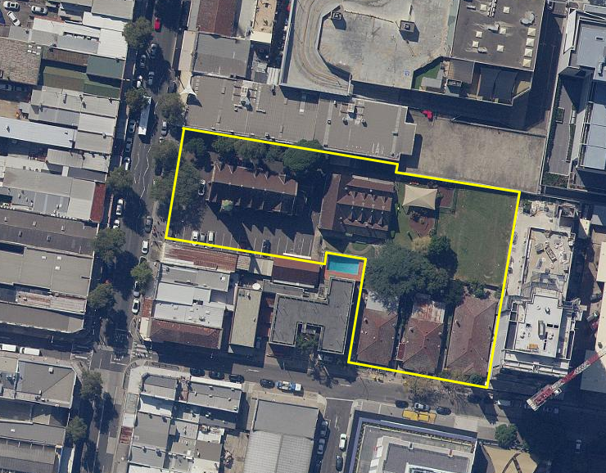
Figure 1: Present Day Aerial image (Source: Six Maps).
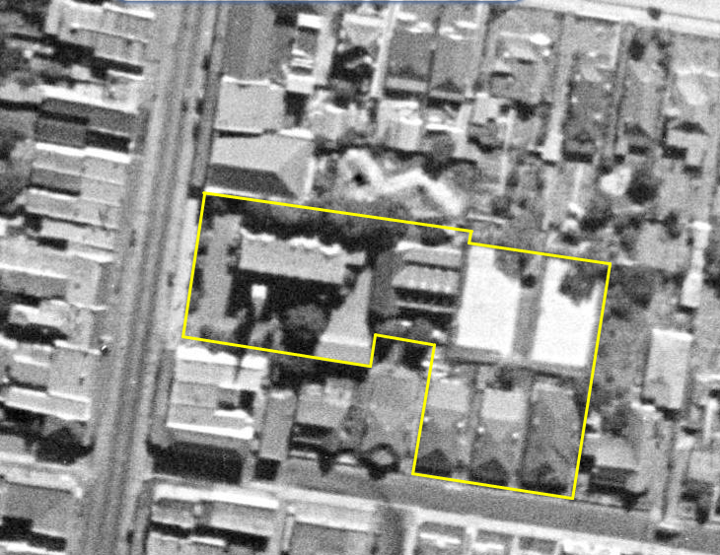
Figure 2: c1943 Aerial image (Source: Six Maps).

STATE ENVIRONMENTAL PLANNING POLICY nO. 65 – DESIGN QUALITY OF RESIDENTIAL APARTMENT DEVELOPMENT
SEPP 65 applies to the proposed development as it is characterised as a ‘residential flat building’ and is three or more storeys and contains four or more dwellings. Clause 28(2) stipulates that the consent authority is to take into consideration the advice of a design review panel (if any), the design quality principles, and the Apartment Design Guide (ADG).

Council does not have a design review panel; however the application was referred to an external Urban Design consultant (GMU) who reviewed various iterations of the proposal.

A discussion of the urban design amendments made to the proposal during the assessment of the application are provided below:

The matters raised by Council’s external urban design consultant, GMU in their review of the initial plans submitted with the concept Development Application are as follows:
Matter | Comment
Height | - Although the maximum height of Building 1 has been reduced from 102m to 91.5m (since the Pre DA-scheme reviewed in 2018), the tower development remains considerably taller than the surrounding buildings and is in breach of the applicable building height control (BLEP).  - Insufficient information has been provided to demonstrate the outcomes and the impacts to the streetscape presentation. Given the prominent location of the site, any future development should demonstrate careful consideration of the context including consideration of the likely future development pattern of adjoining sites and the streetscape proportions.  - While the proposal is not in breach of the building height plane (BLEP Clause 4.3A), GMU understand that the proposal provides a variation of 31.5m to the Maximum Building Height of 60m (BLEP).  - The applicant should demonstrate the capacity for the Concept DA to provide an appropriate contextual response and contribute to a harmonious streetscapes, taking into account both the existing and likely future development scenarios.
Built form distribution and streetscape impacts | - GMU are concerned that the proposal fails to provide a sensitive built form response to the site constraints and the unique qualities of the heritage item in its setting.  - Building No 3 occupies the narrow space between the adjoining property to the north and the church. The proposed built form in this location engulfs the space to the north and east of the church and detracts from the presentation of the church when viewed from Burwood Rd (west). Building No 3 partially obstructs the Church building and prevents the characteristic profile of the church from being read and understood in its entirety when viewed from the northwest (Burwood Rd).  - The proposal relies on the removal of 4 large mature trees which are considered to be a key landscape character element for the Church site when viewed from the Burwood Road interface.  - The height of Building No 2 has been reduced to match the maximum height of the Church spire, as part of the current proposal. We understand that the proposal relies on a nil setback to the southern boundary however, the proposal does not account for the outcome in terms of the likely amalgamation pattern and development capacity of the adjoining properties to the south nor does it demonstrate how the scale and massing of Building No 2 relates to the streetscape presentation for the broader context along Burwood Road.  - Building No 2 provides a continuous 7-storey built form to its northern façade without any secondary setbacks or transition. The continuous built form, the proportions and the proximity to the church exacerbates the abrupt contrast in bulk between the existing (the Church) and the new built form and while the maximum height (of Building No 2) is similar to the height of the church spire, it fails to complement the ornate and unique architectural form of the heritage item.  - The continuous length of the podium of Building 1 exacerbates the perceived bulk to the western interface (facing the laneway) and provides an overbearing backdrop to the Church and the site when viewed from Burwood Rd. Built form breaks and articulation should be introduced as part of the detailed design to minimise visual bulk and scale.  - The streetwall height of Building No 1 to George Street, has been reduced to 18.6m in the current scheme however, this still exceeds the permissible streetwall height of 15m (BDCP 3.3.2.3). The proposed proportions are inconsistent with the street wall heights along George Street which range from 3 to 4 storeys in height.  - The public laneway from Burwood road to George Street is supported in principle.  - GMU understand that the DCP (BDCP 3.9.3) nominates a pedestrian through-site link to be provided to the eastern part of the site.
Setbacks and Separation | - GMU find that the proposal provides insufficient setbacks and separation distances which contributes to the perceived bulk and potential adverse amenity impacts.  - A pedestrian ramp is located to the west of Building No 1 along the boundary of No 35 George Street. A ‘green wall’ is indicated in this location however, the nature of the interface should be documented in greater detail to ensure adverse impacts to the residents of No 35 are minimised.  - The east facing units in the existing development have balconies orientated to the side boundary. The units appear to depend on these balconies as the primary (the only) private open areas and may be severely impacted by the proposed location of the pedestrian link in terms of visual and acoustic privacy as well as outlook pending design of the boundary interface. Sections should be provided showing the proposal and the interface to No 35.  - We note that from Level 4 (5th floor) and above, the west facing windows of Building No 1 should provide setbacks to the boundary of No 35 in accordance with ADG principles.  - The setback should be increased to 9m to ensure that 50% of the required separation distance is provided by the proposal. Adequate building separation is required to minimise visual and acoustic amenity impacts including overlooking to balconies and the communal pool area. The provision of louvers will not sufficiently address the issue and is not supported.  - Building No 2 provides a 7-storey blank wall to the southern interface facing the adjoining residential properties. This is considered to be an unacceptable outcome and the blank wall condition would result in significant adverse impacts to the existing residential development at No 35 George St in terms of visual quality, outcook and solar access.  - The overshadowing diagrams do not clearly demonstrate the impacts associated with the single storey podium of Building No 2. The single storey podium is built to nil setback and is thought to impact the ground floor units in the adjoining property at No 35 and some overshadowing to the communal pool area to the north may also occur in the afternoon. Additional information should be provided.  - The separation distances provided between Building No 3 and the Church is considered to lead to an unacceptable outcome given the visual impacts to the streetscape presentation along Burwood Rd further to previous comments.
Amenity | - The proposal, in its current form, results in a number of adverse amenity impacts to adjoining properties and public domain areas. These include:  - Removal of the (4) large trees along the northern boundary which are characteristic visual elements in the streetscape (Burwood Rd) and form part of the siting of the Church.  - The scale of the streetwall height to George Street is inconsistent with the likely future streetwall heights and does not contribute to a harmonious streetscape or enhancement of the pedestrian scale environment.  - The location of the pedestrian ramp to the east of Building No 2 may result in adverse impacts to the east facing units in the adjoining property (No 35). Building No 2 provides a blank wall condition to the southern interface which will reduce outlook and solar access to the existing units and balconies of 35 George Street.  - The proposal results in additional overshadowing to the north facing units in the existing development located at No 11-15 Deane St. It appears that units are impacted from approximately 10am – 1:30pm mid-winter.  - According to the Indicative Scheme, the communal open space of Building No 1 is located to the south of the tower and which is likely to result in significant self-overshadowing.  - Insufficient information is provided in regard to the proposed restaurant and how the new built forms will relate to the existing building fabric. Additional information should be provided including cross sections showing the building envelopes and separation distances  - The active laneway appears to be overshadowed for the majority of the day.  - Acoustic impacts may be associated with the location of the outdoor play area of the Childcare centre (Indicative Scheme by Turner). Commercial uses located directly above may be impacted and privacy screens should be considered as part of the detailed design stage to prevent overlooking.  - The basement parking extends to the front boundary (George St). The sections provided do not appear to adequately demonstrate the capacity to accommodate mature trees in accordance with the Landscape Concept

On 16 August 2019, the applicant submitted amended plans in response to the above GMU comments. The key design changes to the proposed concept development comprised:
- Amendments to the Public Domain
  - Inclusion of an east-west through-site link from Burwood Road to the north-south through-site link on 29 George Street
  - Revised Landscape Concept Plan
- Amendments to Building 1 (Mixed Use Tower)
  - Expansion of the basement ingress/egress to allow dual vehicles
  - Reduced the street wall height on George street to 15m (DCP compliant)
  - Illustrative internal layout of the ground and upper ground levels re-arranged to accommodate the new through-site link
  - Realignment of the Building 1 envelope to enable further design refinement, including Level 1, 5-7, 8-9, 10-24
- Amendments to Building 3 (Church Administration Building)
  - Increased building separation by 1300mm (to 2,200mm) between the Church and Building 3
  - Inclusion of basement level for the ancillary church administration use, including access to the level 1 Basement.

The amended plans were referred to GMU for further comment on 13 October 2019, and a response was received 17 October 2019. The comments are tabled below:

Matter | Comment
Building Height | To assist Council in determining the acceptability of the proposed height exceedance as part of the evolving character and skyline of the precinct, GMU previously prepared a built form and envelope study (see below Figures 3, 4, 5, & 6) .  The proposed height will not be incongruous with the evolving character of the precinct, especially in light of the recently approved Planning Proposals adjacent to Burwood Library.

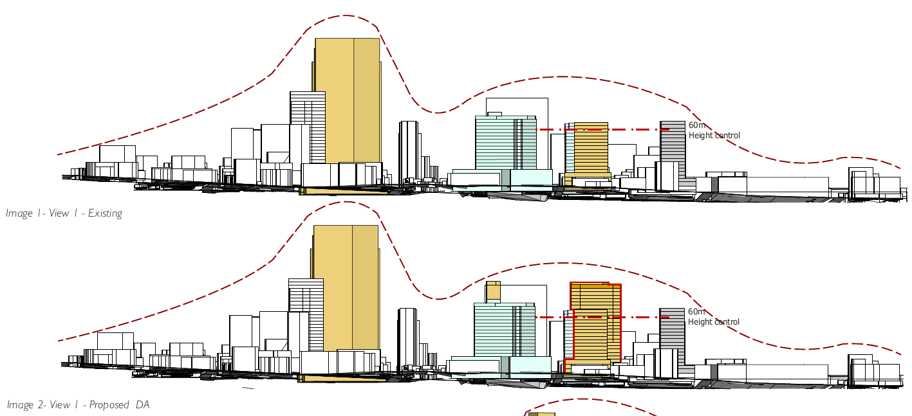
Figure 3: Building Form and Envelope Study. Courtesy: GMU Urban Design

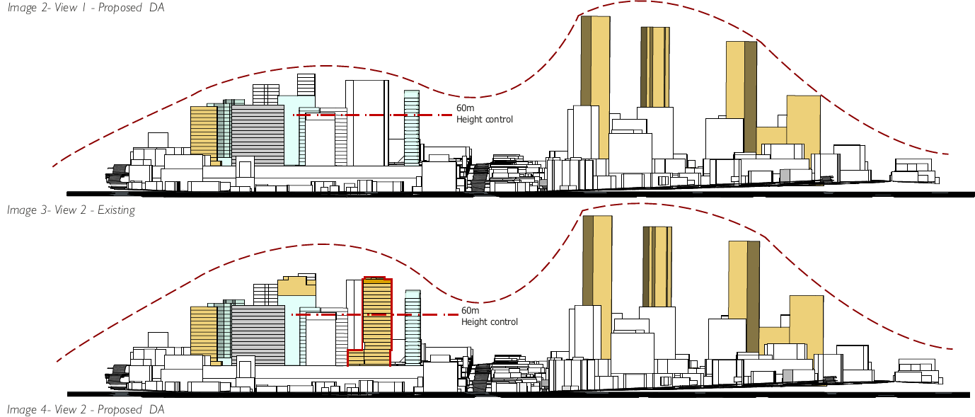
Figure 4: Building Form and Envelope Study. Courtesy: GMU Urban Design

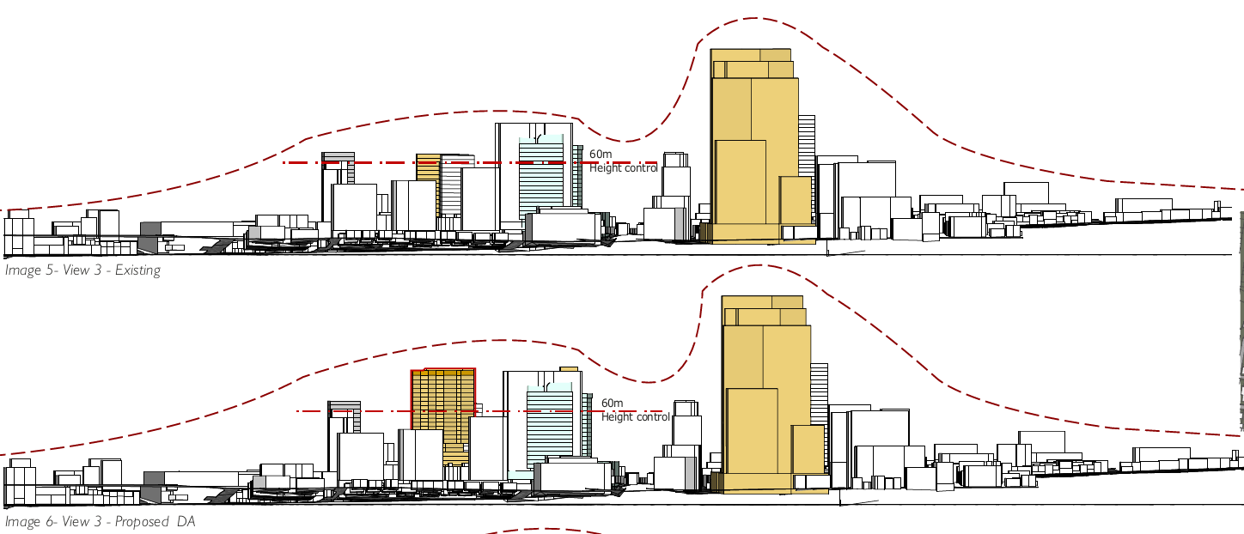
Figure 5: Building Form and Envelope Study. Courtesy: GMU Urban Design

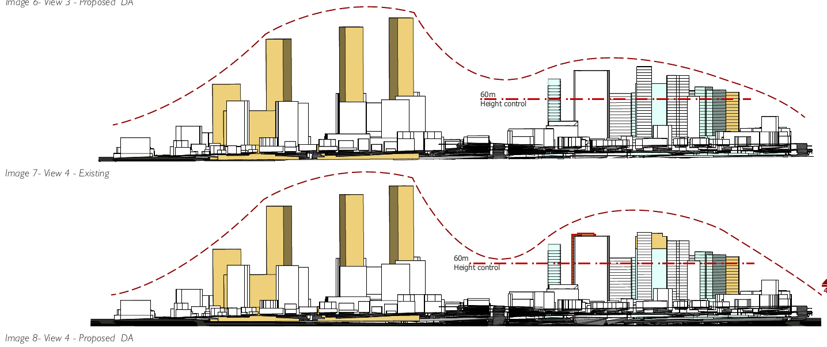
Figure 6: Building Form and Envelope Study. Courtesy: GMU Urban Design

Matter | Comment
Building 3 | While there are some urban design implications with the location and form of Building 3, this is more of a heritage issue, and it requires the input of Council’s heritage officer.
Building 2 | The height of Building No 2 has been reduced to match the maximum height of the church spire, as part of the current proposal. While GMU is satisfied that the spire will retain its visibility in the streetscape, the long-term issue will be the permanent exposure of the blank wall when seen on approach on Burwood Rd.
Height of podium/ skirt facing George St. | The street wall height of Building No 1 to George Street has been reduced to approximately 13m. This is compliant with the permissible street wall height of 15m (BDCP 3.3.2.3). However, the overall massing strategy facing George Street also includes a secondary form setback to 6m above level 3 that takes the extent of the frontage to No 29 up to the communal Open Space Level. GMU will strongly recommend sculpting these levels further to bring forward the tower expression down to the 13m podium and pushing back the other parts of the skirt above the 13m.
Overshadowing of adjacent towers | Further information is required.

The above comments from GMU were provided to the Applicant, and on 20 August 2020, amended plans were received. These plans were not re-referred to GMU as based on an assessment by Council’s Planning officers, and Council’s Heritage Advisor and external heritage consultant the amended plans are considered to have addressed the matters raised by GMU.

This is discussed below, and in further detail under Note 2: Heritage under the Burwood Local Environmental Plan 2012 assessment in this report.

Matter | Comment
Amendments to Building 1 (Mixed Use Tower) | Creation of two distinct elements to the upper tower form providing an appropriate and improved response to the heritage items.  Realignment and reduced depth of the tower slot-cut, to improve the articulation of the tower and subtly define the ‘heritage’ (northern) and ‘contemporary’ (southern) zones of the tower mass;  Reduced height of the ‘heritage’ (northern) tower mass to provide an improved sympathetic backdrop to the heritage listed site; and  The western façade of the southern tower form has been angled south-east.
Amendments to Building 2 (Student Accommodation Building) | Realignment of the awning (as a horizontal element) to the sill and spire window of the church.
Building 3 – Church Gathering and Administration | No changes are proposed to Building 3 (Church Administration Building) or public domain as Council have provided in-principle support for the previously submitted design outcomes.

Design Quality Principles
The amended proposal as detailed above has been assessed against the Design Quality Principles. The proposal is considered to be consistent with the Design Quality Principles and a Design Verification Statement was submitted with the application prepared by Urban Link dated 27 September 2019, outlined in Table 1 below.

Table 1: Design Quality Principles and Applicant’s Response
Principle | Comment | Consistency
Principle 1: Context and neighbourhood character  Good design responds and contributes to its context. Context is the key natural and built features of an area, their relationship and the character they create when combined. It also includes social, economic, health and environmental conditions.  Responding to context involves identifying the desirable elements of an area’s existing or future character. Well-designed buildings respond to and enhance the qualities and identity of the area including the adjacent sites, streetscape and neighbourhood.  Consideration of local context is important for all sites, including sites in established areas, those undergoing change or identified for change. | Applicant’s response:  The concept proposal has been designed to accommodate the retention of the existing Church and School Hall buildings and their heritage significance. The three new buildings have been carefully located to maintain sightlines to the existing buildings, including the church steeple, while optimising the floorspace that can be delivered on the site, consistent with the transitioning character of the locality.  Detailed consideration has been given to the site context and the existing, approved and proposed buildings within the surrounding area. The proposed built form and scale has been designed to be compatible and consistent with the existing and likely future development, as well as providing for a satisfactory amenity outcome, including solar  access/overshadowing, visual privacy, etc.  The site is well-located within a town centre environment, close to high- frequency public transport, employment, services and educational establishments. The proposed mixed-use development, including residential apartments, is considered entirely appropriate for the site context and the character of the neighbourhood. | Yes  Yes  Yes
Principle 2: Built form and scale  Good design achieves a scale, bulk and height appropriate to the existing or desired future character of the street and surrounding buildings.  Good design also achieves an appropriate built form for a site and the building’s purpose in terms of building alignments, proportions, building type, articulation and the manipulation of building elements.  Appropriate built form defines the public domain, contributes to the character of streetscapes and parks, including their views and vistas, and provides internal amenity and outlook. | Applicant’s response:  The proposed built form and scale is consistent and compatible with the existing and desired future character of the street and surrounding buildings. Detailed consideration is given these issues within  Section 4.11.1 as well as the clause 4.6  request that has been prepared in support of the proposed variation to the maximum building height (refer to Appendix C).  The siting and configuration of the concept building envelopes will facilitate the optimal delivery of the future residential floorspace in a manner that protects the heritage significance of the existing buildings, while providing for additional housing supply.  The potential environmental impacts have been assessed in detail and it is considered that the future buildings will make a positive contribution to the city skyline. Further the proposed landscape works and through- site connection will enhance the pedestrian experience and improvements to the public realm. | Yes
Principle 3: Density  Good design achieves an appropriate built form for a site and the building’s purpose, in terms of building alignments, proportions, building type and the manipulation of building elements.  Appropriate built form defines the public domain, contributes to the character of streetscapes and parks, including their views and vistas, and provides internal amenity and outlook | Applicant’s response:  The future detailed DA(s) will document the level of amenity that will be achieved for residents and each apartment. However, the concept proposal has been designed to facilitate future compliance in accordance with the design principles and the ADG.  The proposed floorspace complies with the maximum and residential FSR controls prescribed by the LEP. | Yes
Principle 4: Sustainability  Good design combines positive environmental, social and economic outcomes.  Good sustainable design includes use of natural cross ventilation and sunlight for the amenity and liveability of residents and passive thermal design for ventilation, heating and cooling reducing reliance on technology and operation costs. Other elements include recycling and reuse of materials and waste, use of sustainable materials and deep soil zones for groundwater recharge and vegetation. | Applicant’s response:  The general configuration and layout of the building envelopes as shown within the concept proposal have been designed to maximise access to natural daylight, natural cross ventilation and passive thermal design.  The future detailed DA will outline the specific measures to be incorporated regarding sustainability. Consideration has been given to the potential operational waste of the individual land use activities, as outlined in Section 4.11.8. | Yes
Principle 5: Landscape  Good design recognises that together landscape and buildings operate as an integrated and sustainable system, resulting in attractive developments with good amenity. A positive image and contextual fit of well-designed developments is achieved by contributing to the landscape character of the streetscape and neighbourhood.  Good landscape design enhances the development’s environmental performance by retaining positive natural features which contribute to the local context, coordinating water and soil management, solar access, micro-climate, tree canopy, habitat values and preserving green networks.  Good landscape design optimises useability, privacy and opportunities for social interaction, equitable access, respect for neighbours’ amenity and provides for practical establishment and long term management. | Applicant’s response:  A Landscape Concept Report has been prepared by Place Design Group which outlines the overall landscape concept for the development site. This includes a through-site link that will improve the pedestrian permeability of the site and bespoke furniture and landscaping to encourage the use of the central open space as a place for spiritual pause and reflection.  The proposed landscape design also includes the treatment of the communal spaces on the upper floors of Buildings 1 and 2 which will accommodate residential apartments and student housing. The proposed layout and concept design seeks to embrace the site orientation, as well as the future building design.  An Access Review has been completed which demonstrates the future detailed proposal(s) will be able to achieve equitable access. All detailed works, including ongoing maintenance, will be documented within the future DA(s). | Yes
Principle 6: Amenity  Good design positively influences internal and external amenity for residents and neighbours. Achieving good amenity contributes to positive living environments and resident wellbeing.  Good amenity combines appropriate room dimensions and shapes, access to sunlight, natural ventilation, outlook, visual and acoustic privacy, storage, indoor and outdoor space, efficient layouts and service areas and ease of access for all age groups and degrees of mobility. | Applicant’s response:  The configuration and layout of the building envelopes have been designed to achieve a satisfactory level of amenity for the future residential apartments, as well as the amenity of existing, approved and proposed uses within the immediate locality. This has been demonstrated by the illustrate layouts.  Detailed apartment layouts will be shown with the detailed proposal and subject to further detailed assessment in association with the related future DA. | Yes
Principle 7: Safety  Good design optimises safety and security within the development and the public domain. It provides for quality public and private spaces that are clearly defined and fit for the intended purpose. Opportunities to maximise passive surveillance of public and communal areas promote safety.  A positive relationship between public and private spaces is achieved through clearly defined secure access points and well-lit and visible areas that are easily maintained and appropriate to the location and purpose. | Applicant’s response:  The proposed mix and location of the various land use activities have been designed to provide for the activation of the ground plane and the natural surveillance of the public domain and through-site pedestrian link. The retail/restaurant uses and associated dining area will be oriented to the street and the central part of the site, with clear and legible wayfinding to the various buildings on the site.  The proposed landscape concept has been designed to facilitate the public use of the site, including furniture and spaces that embrace and encourage greater interaction between the church congregation and the local community. | Yes
Principle 8: Housing diversity and social interaction  Good design achieves a mix of apartment sizes, providing housing choice for different demographics, living needs and household budgets.  Well-designed apartment developments respond to social context by providing housing and facilities to suit the existing and future social mix.  Good design involves practical and flexible features, including different types of communal spaces for a broad range of people and providing opportunities for social interaction among residents | Applicant’s response:  The future detailed proposal will document that proposed mix of apartment sizes and housing choice suitability for the locality. The illustrate floor plans demonstrate that the appropriate mix can be achieved.  The proposed ground level and upper level open spaces provide opportunities for future residents to engage with other occupants across the site and the local community, as well as residents within their own building. | Yes
Principle 9: Aesthetics  Good design achieves a built form that has good proportions and a balanced composition of elements, reflecting the internal layout and structure. Good design uses a variety of materials, colours and textures.  The visual appearance of a well-designed apartment development responds to the existing or future local context, particularly desirable elements and repetitions of the streetscape. | Applicant’s response:  The concept proposal provides a commitment to design excellence. The detailed architectural design elements will be resolved and shown within the detailed proposal and associated DA. | Yes

Apartment Design Guide (ADG)

As the proposed development contains a residential flat building of three or more storeys and four or more dwellings, the provisions of the Apartment Design Guide (ADG) are applicable. The ADG contains objectives, design criteria and design guidelines for residential apartment development. The development has been assessed against the relevant key design criteria within Parts 3 and 4 of the ADG in Table 2 below:

Table 1: Design Quality Principles and Applicant’s Response
Principle | Comment | Consistency
Principle 1: Context and neighbourhood character  Good design responds and contributes to its context. Context is the key natural and built features of an area, their relationship and the character they create when combined. It also includes social, economic, health and environmental conditions.  Responding to context involves identifying the desirable elements of an area’s existing or future character. Well-designed buildings respond to and enhance the qualities and identity of the area including the adjacent sites, streetscape and neighbourhood.  Consideration of local context is important for all sites, including sites in established areas, those undergoing change or identified for change. | Applicant’s response:  The surrounding area is characterised by a mix of building forms and styles including, low scale residential housing (of brick and fibro), mixed use developments and services such as schools and train station.  The area is undergoing a significant transition into a higher density area consisting of medical, education, retail, commercial and residential uses. It is likely that the area will experience a transition in densities such as that proposed in this application to meet the objectives of the Burwood Town Centre controls. Within this context the proposal will sit well, contribute and act as precedence in a positive manner to the quality and identity of the precinct.  The zoning and relevant built form controls allow for the style of building proposed and responds to the desired future character as articulated by the DCP. | Yes
Principle 2: Built form and scale  Good design achieves a scale, bulk and height appropriate to the existing or desired future character of the street and surrounding buildings.  Good design also achieves an appropriate built form for a site and the building’s purpose in terms of building alignments, proportions, building type, articulation and the manipulation of building elements.  Appropriate built form defines the public domain, contributes to the character of streetscapes and parks, including their views and vistas, and provides internal amenity and outlook. | Applicant’s response:  The building scale, bulk and height responds to the future character of the street and surrounding buildings.  The building sits below the DCP height planes including the 36⁰ Shaftesbury Rd plane that was put in place to mitigate overshadowing over the R2 zone.  The building fits well with the desired streetscape in term of bulk, scale. The bulk and scale of the building is ameliorated with the building being articulated through the composition of elements and materials to create less perceived bulk to the building. The building massing and facades are articulated to break down the scale and create a building identity, while maintaining the surrounding amenity.  The street will have vegetation over the promenade to contrast and soften the experience at a human scale, adding positively to the public domain. The proposed thoroughfare will consist of deep soil zones that allow for growth of large trees to mitigate visual and acoustic privacy as well as providing a pleasurable experience for the occupants of the space.  Multiple communal open spaces with different offerings on level 3 and level 21 provide excellent internal amenity and outlook. | Yes
Principle 3: Density  Good design achieves an appropriate built form for a site and the building’s purpose, in terms of building alignments, proportions, building type and the manipulation of building elements.  Appropriate built form defines the public domain, contributes to the character of streetscapes and parks, including their views and vistas, and provides internal amenity and outlook | Applicant’s response:  The achieved density is a function of the tangible public benefits under council’s current Sydney Region Growth Centre SEPP. The proposed building is an opportunity to achieve density that is consistent with the desired future character of the area and can be sustained by excellent access to public transport, amenities and jobs.  The proposed density is appropriate to its location, meets the minimum densities as defined in the DCP and in the context of the neighbouring buildings. It makes good use of its proximity to public transport via train and bus, amenities and jobs. | Yes
Principle 4: Sustainability  Good design combines positive environmental, social and economic outcomes.  Good sustainable design includes use of natural cross ventilation and sunlight for the amenity and liveability of residents and passive thermal design for ventilation, heating and cooling reducing reliance on technology and operation costs. Other elements include recycling and reuse of materials and waste, use of sustainable materials and deep soil zones for groundwater recharge and vegetation. | Applicant’s response:  It is apparent that the proposal promotes the longer term sustainability of the local area  Natural ventilation compliance under the ADG is achieved by suitably designed double oriented apartments with reliable exposure to the relevant summer cooling breezes in Burwood.  Over 2 hours of sun are provided to majority of units between 9-3pm on the 21st June as per the ADG guidelines and a significant proportion achieve some sunlight between these hours. Balconies provide shelter from the summer sun while allowing winter sun to penetrate well into living areas. This will reduce the need for mechanical heating and cooling.  Communal open space is provided at level 3 and 21 terrace receiving the required hours of solar. | Yes
Principle 5: Landscape  Good design recognises that together landscape and buildings operate as an integrated and sustainable system, resulting in attractive developments with good amenity. A positive image and contextual fit of well-designed developments is achieved by contributing to the landscape character of the streetscape and neighbourhood.  Good landscape design enhances the development’s environmental performance by retaining positive natural features which contribute to the local context, coordinating water and soil management, solar access, micro-climate, tree canopy, habitat values and preserving green networks.  Good landscape design optimises useability, privacy and opportunities for social interaction, equitable access, respect for neighbours’ amenity and provides for practical establishment and long term management. | Applicant’s response:  All of the proposed units still have access to outdoor balconies and/or terraces, some with various aspects. Communal open spaces on level 3 and 21 terraces are incorporated into the development providing a range of recreational opportunities for future residents.  Large canopy trees are provided along the thoroughfare and partly on the main road, continuing the existing green spine on Victoria St. Planter boxes are also provided along the top of the promenade to provide an inviting green belt. | Yes
Principle 6: Amenity  Good design positively influences internal and external amenity for residents and neighbours. Achieving good amenity contributes to positive living environments and resident wellbeing.  Good amenity combines appropriate room dimensions and shapes, access to sunlight, natural ventilation, outlook, visual and acoustic privacy, storage, indoor and outdoor space, efficient layouts and service areas and ease of access for all age groups and degrees of mobility. | Applicant’s response:  The proposed units will still have considerable internal amenity and achieves the minimum sizes contained within the Apartment Design Guide. They are of a sufficient size and appropriate room dimensions to meet the needs of future occupants. Storage is provided within all units and with some additional space within the basements. The outdoor areas (communal and private) are of sufficient size to meet the recreational needs of future occupants.  The building has been designed in compliance with the principal development standards to achieve high levels of internal and external amenity with more than 70% of units achieving the solar access requirements, and over 60% to achieve cross ventilation.  The proposed building has been provided with setbacks to limit overshadowing, maximise solar access and minimise privacy and overlooking impacts. | Yes
Principle 7: Safety  Good design optimises safety and security within the development and the public domain. It provides for quality public and private spaces that are clearly defined and fit for the intended purpose. Opportunities to maximise passive surveillance of public and communal areas promote safety.  A positive relationship between public and private spaces is achieved through clearly defined secure access points and well-lit and visible areas that are easily maintained and appropriate to the location and purpose. | Applicant’s response:  The principles of Crime Prevention through Environmental, Design include the consideration of Natural Surveillance, Natural Access Control and Natural Territorial Reinforcement as demonstrated below:  Surveillance - The development embodies good levels of casual surveillance from within the building and from the street. The proposed building and landscaping design do not create any concealment areas.  Access - The main ground level entry will be secured and fitted with a telecom for visitors. The entry to the building lobby is accessed from the street frontages of the property and is fully glazed, maximizing the potential for casual surveillance. Access to the basement is by a secured roller door, which again is fitted with an intercom entry system for visitors. Access from secured garages is available to all units above. The lifts will be restricted to resident use only by coded key cards and similarly for commercially dedicated lifts. Generally, the proposed layout provides a high level of privacy and security. Adequate lighting to be provided for the lobby, car parks and communal open spaces, details will be submitted with the CC documents.  Territorial Reinforcement:  The proposed development and its presentation to the street make it clearly identifiable by the public. The proposed development is considered to represent a satisfactory outcome in terms of security and crime prevention.  We can conclude that the proposed development has been designed in accordance with the objectives and better design practice of the Crime Prevention through Environmental Design (CPTED). | Yes
Principle 8: Housing diversity and social interaction  Good design achieves a mix of apartment sizes, providing housing choice for different demographics, living needs and household budgets.  Well-designed apartment developments respond to social context by providing housing and facilities to suit the existing and future social mix.  Good design involves practical and flexible features, including different types of communal spaces for a broad range of people and providing opportunities for social interaction among residents | Applicant’s response:  The proposed design incorporates various dwelling sizes and shapes, with units capable of adaption and meeting the liveable housing level required, thereby promoting diversity, affordability and access to housing choice. | Yes
Principle 9: Aesthetics  Good design achieves a built form that has good proportions and a balanced composition of elements, reflecting the internal layout and structure. Good design uses a variety of materials, colours and textures.  The visual appearance of a well-designed apartment development responds to the existing or future local context, particularly desirable elements and repetitions of the streetscape. | Applicant’s response:  As discussed in the Architect Design Statement the design has an excellent composition of elements to create a highly articulated façade and of high aesthetic value.  Finishes have been selected to compliment the elements they envelope and to create a modern yet not overpowering contribution to the streetscape and architectural quality in the area.  Bulk and scale is controlled through use of elements such as blades, projected balconies with transparent, and solid balustrade, a feature textured ‘ribbon balcony. The podium elements are empathetic to the streetscape of Burwood Rd and ground the building to create a human scale at ground level. | Yes

Apartment Design Guide (ADG)

As the proposed development contains a residential flat building of three or more storeys and four or more dwellings, the provisions of the Apartment Design Guide (ADG) are applicable. The ADG contains objectives, design criteria and design guidelines for residential apartment development. The development has been assessed against the relevant key design criteria within Parts 3 and 4 of the ADG in Table 2 below:

Table 2: Assessment of the proposed development against the ADG
Objective | Requirement | Proposed | Compliance
3A  Site Analysis | Site analysis illustrates that design decisions have been based on opportunities and constraints of the site conditions and their relationship to the surrounding context. | The SEE and amended planning documentation provides a comprehensive description of the design rationale which underpinned the concept proposal, including the heritage significance of the retained buildings, the height of buildings along the Burwood Road streetscape and the transitioning scale and character of development within the Burwood Town Centre. | Yes
3B  Orientation | Building types and layouts respond to the streetscape and site while optimising solar access within the development.  Overshadowing of neighbouring properties is minimised during mid-winter | The three building envelopes have been carefully located to enable activation of the Burwood Road streetscape, while protecting the heritage significance of the existing church building.  Building 1 (which comprises the residential apartments) is oriented to optimise potential solar access, while minimising potential impacts on the amenity of surrounding properties, including overshadowing, visual privacy and the like. | Yes
3C  Public Domain Interface | Transition between private and public domain is achieved without compromising safety and security.  Amenity of the public domain is retained and enhanced | The layout of individual apartments will be resolved within the detailed proposal and assessed by way of a separate future DA. However, the concept proposal has been designed to facilitate compliance with the ADG requirements.  The Concept DA is accompanied by a Landscape Concept Report (issued August 2019) which outlines the proposed treatment of the future communal open spaces.  The layout of individual apartments, building entries and car park will be resolved within the detailed proposal and assessed by way of a separate future DA. However, the concept proposal has been designed to facilitate compliance with the ADG requirements. | Yes
3D  Communal and Public Open Space | Communal open space has a minimum area equal to 25% of the site.  Developments achieve a minimum of 50% direct sunlight to the principal usable part of the communal open space for a minimum of 2 hours between 9 am and 3pm on 21 June (mid-winter).  Communal open space is designed to allow for a range of activities, respond to site conditions and be attractive and inviting.  Communal open space is designed to maximise safety.  Public open space, where provided, is responsive to the existing pattern and uses of the neighbourhood. | The concept proposal provides two separate communal open space areas, one area 452sqm on Level 8, and one area 289sq.m on Level 22 (roof).  The Concept DA is accompanied by a Landscape Concept Report (submitted August 2019) which outlines the location and landscaped treatment of the future communal open spaces.  The detailed numeric requirements will be addressed within the detailed proposal and assessed by way of a separate future DA. However, the concept proposal has been designed to facilitate future compliance with the ADG requirements.  The Concept DA is accompanied by a Landscape Concept Report which outlines the location and landscaped treatment of the future communal open spaces.  The detailed design and amenity outcomes will be outlined within the detailed proposal and assessed by way of a separate future DA. However, the concept proposal has been designed to facilitate compliance with the ADG requirements. | Yes
3E  Deep Soil Zones | On sites with areas >1,500m², 7% of the site area is to be deep soil with a minimum 6m dimension. | The Concept DA includes a large central plaza that will include deep soil zones. The detailed design, including the compliance with the numeric control, will be outlined within the detailed proposal and assessed by way of a separate future DA. However, the concept proposal has been designed to facilitate compliance with the ADG requirements. | TBC
3F  Visual Privacy | The ADG prescribes minimum separation distances between buildings:  - Up to 12m (4 storeys) - 6m (habitable) / 3m (non-habitable)  - Up to 25m (5-8 storeys) - 9m (Habitable) / 4.5m (non-habitable)  - Over 25m (9+ storeys) - 12m (Habitable) / 6m (non-habitable)  No separation is required between blank walls.  Site and building design elements increase privacy without compromising access to light and air and balance outlook and views from habitable rooms and private open space. | The Concept DA provides setback distances from Building 1 to the site boundaries including:  - 6.11 metres from the Level 4 and Level 5 apartments to the northern boundary  - 9.1 metres from the upper level apartments to the western boundary  - 9.505 metres from the Level 4 terraces to the eastern boundary  - 9.405 metres from the upper level apartments to the southern boundary/George Street  - 13.53-14.1 metres from the upper level apartments to the eastern boundary.  Screening will be provided where required to achieve appropriate levels of visual privacy between apartments and adjoining properties. This will be further resolved within the detailed proposal and assessed by way of a separate future DA.  The concept proposal outlines potential privacy screening measures that will facilitate visual privacy to adjoining properties, while providing for adequate light, air, private open space and amenity for individual apartments. This will be further resolved within the detailed proposal and assessed by way of a separate future DA. | On Merit
3G  Pedestrian Access and Entries | Building entries and pedestrian access connects to and addresses the public domain.  Access, entries and pathways are accessible and easy to identify.  Large sites provide pedestrian links for access to streets and connection to destinations. | The concept proposal includes a resident lobby within George Street, providing a clear address and a legible entry to Building 1.  A through site connection is provided through the site, providing direct access to the retail, restaurant and services provided on the site, as well as Burwood Road.
3H  Vehicle Access | Vehicle access points are designed and located to achieve safety, minimise conflicts between pedestrians and vehicles and create high quality streetscapes | Vehicle access will be provided via George Street, minimising potential conflicts with pedestrian movements and activity along Burwood Road, as well as providing for a high quality streetscape that minimise impacts on the heritage significance of the existing buildings.
3J  Bicycle and Car Parking | For development in the following locations:  on sites that are within 800 metres of a railway station or light  rail stop in the Sydney Metropolitan Area;  or  on land zoned, and sites within 400 metres of land zoned, B3  Commercial Core, B4 Mixed Use or equivalent in a nominated regional centre;  The minimum car parking requirement for residents and visitors is set out in the Guide to Traffic Generating Developments, or the car parking requirement prescribed by the relevant council, whichever is less.  Parking and facilities are provided for other modes of transport | The Traffic and Parking Assessment previously provided by TTPA (in March 2020) confirms that adequate on-site car parking can be provided to accommodate all land use activities proposed within the Concept DA.  Bicycle parking will be provided at-grade and within the basement car park. The final layout will be resolved in the detailed proposal and assessed by way of a separate future DA.
4A  Solar and Daylight Access | Living rooms and private open space areas of at least 70% of apartments receive a minimum of 2 hours direct sunlight between 9am and 3pm at mid-winter.  A maximum of 15% of apartments in a building receive no direct sunlight between 9am and 3pm at midwinter. | The layout of individual apartments will be resolved within the detailed proposal and assessed by way of a separate future DA. However, the concept proposal has been designed to facilitate compliance with the ADG requirements for natural ventilation.  To be confirmed at DA stage. | Yes – Refer Note 1 below table.
4B  Natural Ventilation | At least 60% of apartments are naturally cross ventilated in the first nine storeys of the building. Apartments at ten storeys or greater are deemed to be cross ventilated  Overall depth of a cross-over or cross-through apartment does not exceed 18m measured glass line to glass line. | The layout of individual apartments will be resolved within the detailed proposal and assessed by way of a separate future DA. However, the concept proposal has been designed to facilitate compliance with the ADG requirements for natural ventilation.  To be confirmed at DA stage. | TBC
4C  Ceiling Heights | Habitable rooms: 2.7m.  Non-habitable: 2.4m.  If located in mixed use areas: 3.3m for ground and first floor to promote future flexibility of use. | The design of individual apartments will be resolved within the detailed proposal and assessed by way of a separate future DA. However, the concept proposal has been designed to facilitate compliance with the ADG requirements for ceiling heights.  To be confirmed at DA stage. | TBC
4D  Apartment Size and Layout | Apartments are required to have the following minimum internal areas:  Studios: 35m²  1 bedroom: 50m²  2 bedroom: 70m²  3 bedroom: 90m²  The minimum internal areas include only one bathroom. Additional bathrooms increase the minimum internal area by 5m².  In open plan layouts (where the living, dining and kitchen are combined) the maximum habitable room depth is 8 metres from a window.  The width of cross-over or cross-through apartments are at least 4m internally to avoid deep narrow apartment layouts. | The concept proposal has been designed to facilitate compliance with the ADG requirements for minimum apartment sizes. The window placements and habitable room depths will be resolved within the detailed proposal and assessed by way of a separate future DA.  To be confirmed at DA stage. | TBC
4E  Private Open Space and Balconies | All apartments are required to have primary balconies as follows:  Studios: 4m² minimum area.  1 bedroom apartments: 8m² minimum area, 2m minimum depth.  2 bedroom apartments: 10m² minimum area, 2m minimum depth.  3+ bedroom apartments: 12m² minimum area, 2.4m minimum depth.  Ground level or podium apartments are to have a minimum POS area of 15sq.m and minimum depth of 3m. | The concept proposal has been designed to facilitate compliance with the ADG requirements for minimum balcony sizes and dimensions, liveability and solar access. Balconies have been designed to add visual interest to Building 1, as well as maintain solar compliance for the properties to the south.  To be confirmed at DA stage. | TBC
4F  Common Circulation and Spaces | The maximum number of apartments off a circulation core on a single level is eight.  For buildings of 10 storeys and over, the maximum number of apartments sharing a single lift is 40. | The concept proposal includes up to 10 apartments from a single lift core with three passenger lifts. However, the L- shaped design means that there will be a north-south hallway and an east-west hallway, achieving a good level of amenity and natural daylight. | On Merit
4G  Storage | In addition to storage in kitchens, bathrooms and bedrooms, the following storage is provided:  Studio: 4m³  1 bedroom: 6m³  2 bedroom: 8m³  3+ bedroom: 10m³  At least 50% of the required storage is to be located within the apartment. | The concept proposal has been designed to facilitate compliance with the ADG requirements for storage. The final locations and calculations will be provided within the detailed proposal and assessed by way of a separate future DA.  To be confirmed at DA stage. | TBC
4J Noise and Pollution | In noisy or hostile environments the impacts of external noise and pollution are minimised through the careful siting and layout of buildings.  Appropriate noise shielding or attenuation techniques for the building design, construction and choice of materials are used to mitigate noise transmission. | Building 1 is located at the rear of the site, away from Burwood Road. The required acoustic attenuation measures will be resolved and assessed by way of a separate future DA.
4K  Apartment Mix | A variety of apartment types are provided. | The concept proposal has been designed to facilitate an appropriate apartment mix that caters for likely future demands. The final mix will be resolved and assessed by way of a separate future DA for the construction of Building 1 | Yes
4M  Facades | Building facades provide visual interest along the street while respecting the character of the local area. | The architectural design and façade treatment will be resolved in the detailed proposal and assessed by way of a separate future DA.
4N  Roof Design | Roof treatments are integrated into the building design and positively respond to the street.  Opportunities to use roof space for residential accommodation and open space are maximized. | The roof treatment will be resolved within the detailed proposal and assessed by way of a separate future DA. | Yes
4O  Landscape Design | Landscape design is viable and sustainable. | The Concept DA includes a landscape treatment that responds to the site conditions. | Yes
4P  Planting on Structures | Appropriate soil profiles are provided.  Plant growth is optimised with appropriate selection and maintenance.  Planting on structures contributes to the quality and amenity of communal and public open spaces. | The Concept DA is accompanied by a Landscape Concept Report (submitted August 2019) which shows the location and treatment of future communal open spaces. The detailed landscape design will be outlined within the detailed proposal and assessed by way of a separate future DA. | Yes
4Q  Universal Design | Universal design features are included in apartment design to promote flexible housing for all community members.  A variety of apartments with adaptable designs are provided.  Apartment layouts are flexible and accommodate a range of lifestyle needs. | The Access Review (previously submitted) confirms that the concept proposal has been designed to facilitate compliance with the relevant access requirements. The detailed apartment layouts will be outlined within the detailed proposal and assessed in a separate future DA. | Yes
4S Mixed Use | Mixed use developments are provided in appropriate locations and provide active street frontages that encourage pedestrian movement.  Residential levels of the building are integrated within the development, and safety and amenity is maximised for residents. | The mixed-use development is appropriately located within Burwood Town Centre close to public transport and existing services. The mix and location of land use activities has been well-considered having regard to relevant amenity impacts. | Yes
4T  Awnings and Signage | Awnings are well located and complement and integrate with the building design.  Signage responds to the context and desired streetscape character. | The awning locations will be resolved in the detailed proposal and assessed by way of a separate future DA. | Yes
4U Energy Efficiency | Development incorporates passive environmental design.  Development incorporates passive solar design to optimise heat storage in winter and reduce heat transfer in summer.  Adequate natural ventilation minimises the need for mechanical ventilation. | The concept proposal has been designed to achieve energy efficiency principles. The final measures will be resolved in the detailed proposal and assessed by way of a separate future DA. | Yes
4V  Water Management and Conservation | Potable water use is minimized.  Urban stormwater is treated on site before being discharged to receiving waters.  Flood management systems are integrated into site design. | The concept proposal has been designed to achieve water efficiency principles. The final measures will be resolved in the detailed proposal and assessed in a future DA. | Yes
4W  Waste Management | Waste storage facilities are designed to minimise impacts on the streetscape, building entry and amenity of residents.  Domestic waste is minimised by providing safe and convenient source separation and recycling. | The Concept DA includes an operational waste management plan to minimise domestic waste and provide for its effective management and collection. The final measures will be resolved in the detailed proposal and assessed by way of a separate future DA. | Yes
4X  Building Maintenance | Building design detail provides protection from weathering.  Systems and access enable ease of maintenance.  Material selection reduces ongoing maintenance costs. | The proposed building maintenance will resolved in the detailed proposal and assessed in a separate future DA. | Yes

Note 1 - 4A Solar and Daylight Access
The amended Concept DA includes a comprehensive assessment of the proposed impacts of the building envelopes regarding solar access and overshadowing. Solar access plans have been provided in plan view, and Sun Eye Diagrams have also been submitted and prepared on hourly intervals between 9am and 3pm on June 21.

Proposed Buildings 2 & 3 are significantly lower than the maximum 60m permitted building height under BLEP 2012. The mixed-use retail and student housing (boarding house) building to the south (Building 2) has a maximum height of 24.9m. The Church administration building to the north (Building 3) has a maximum height of 7.1m. The potential overshadowing impacts of these buildings is considerably less than what would be expected within the town centre and having regard to their maximum potential height.

Building 1 (Tower Building) proposes to vary from the prescribed control and has a maximum building height of 91.5m above natural ground level. Detailed and careful consideration has been given to the potential impacts of this building and the variation to the height control, particularly regarding solar and overshadowing. The shadow diagrams submitted indicate the potential shadow impacts are generally consistent with the shadows cast by approved development within the surrounding area, including the developments along Deane Street.

While the building will result in shadow impacts, the site orientation and the reduced height of Building 2 means that the residential apartments immediately to the south (11-15 Deane Street) will still enjoy solar access either early morning or late afternoon. The property to the east 29 George Street has also been assessed in detail and it is concluded that the proposal will maintain ADG compliance with the solar access control as demonstrated in the Sun Eye Diagrams prepared by TURNER. In this regard, the proposal is considered to be acceptable in relation to solar and daylight access.

Burwood Local Environmental Plan 2012
The Burwood Local Environmental Plan 2012 came into effect on 9 November 2012. Burwood LEP 2012 contains a number of controls including some numerical development standards which apply to the proposed development. A summary of the assessment of the application against the relevant planning controls within LEP 2012 is shown in Table 3 below.

Table 3: Assessment of the proposed development against Burwood LEP 2012
Clause | Assessment of Proposal | Compliance
2.3 Zone objectives and Land Use Table  Zone B4 Mixed Use  • To provide a mixture of compatible  land uses.  • To integrate suitable business,  office, residential, retail and other development in accessible locations so as to maximise public transport patronage and encourage walking and cycling.  Permitted with consent include:  • Boarding houses  • Centre-based child care facilities  • Commercial premises  • Community facilities  • Medical centres  • Residential flat buildings  • Shop top housing  • Any other development not  specified in item 2 or 4  Places of public worship are not listed in item 2 or 4 and accordingly, are permitted with consent | The proposal as amended, maintains the land use activities of the original submission. These uses are permitted with consent and consistent with the B4 land use objectives as:  - The proposal comprises a mix of compatible uses.  - The existing place of public worship will be retained and complemented by non- residential activities on the ground and lower levels of the existing and proposed buildings to activate the town centre and the streetscape, provide employment and training opportunities and the expansion of the existing community services.  - The proposal also includes residential apartments and student housing, providing for a diverse residential population.  - The proposal provides for employment-generating development and residential dwellings in an appropriate and accessible location, close to high- frequency public transport including heavy rail, and local and regional bus services.  - The site improvements works include a through-site link which will improve pedestrian and cycle connections to and through the Burwood Town Centre. | Yes
4.1 Minimum subdivision lot size  Minimum 500 square metres | The proposal will amalgamate nine (9) existing lots into one lot which will have a site area of 5,028sq.m. | Yes
4.3 Height of Buildings  Maximum 60 metres | The proposal comprises three new buildings, with the following maximum building heights:  • Building 1 - 91.28 metres  • Building 2 – 24.9 metres  • Building 3 – 5.33 metres  The proposed maximum building height of 91.28 metres represents a proposed variation of 31.28 metres (or 52%) to the southern tower zone of Building 1, and 76.08 metre maximum height to the northern tower zone, which represents a proposed variation of 16.07 metres (or 26.8%).  The other two buildings are significantly less than the maximum – Building 2 is 35 metres less than the maximum while Building 3 is 54.67 metres less than the maximum height. | No – Clause 4.6 is Refer Note 1 and Attachment A
4.3A Building Height Plane  Height is not to exceed the building height plane in “Area A”..  BHP projects west from a starting height of 1m from the eastern side of Shaftesbury Road at 36 degrees across the site. | The proposal as amended, continues to comply with the maximum Building Height Plane as originally submitted. | Yes
4.4 Floor space ratio Maximum 4.5:1 | The amended proposal has a total FSR of 3.94:1.  This is 0.56:1 less than the maximum FSR control, and is a reduction of 0.15:1 to the previously submitted documentation. | No
4.4A Exceptions to Floor space ratio  3:1 residential FSR  (a) to limit the density of residential development in certain business zones to ensure that it does not dominate non- residential development in those zones,  (b) to limit the floor space of serviced apartments in certain business zones to ensure that they do not dominate service- providing and employment-generating commercial premises in those zones. | The proposal has a residential FSR of 2.76:1, including the residential apartments and student housing, which complies with the maximum control.  This is a reduction of 0.14:1 to the previously submitted documentation. | Yes
5.10 Heritage Conservation  Various requirements for development of heritage items, heritage conservation area, or within the vicinity of heritage items. | The Church and School Hall buildings on Lot 1 in DP795259 are collectively listed as a local heritage item under the Burwood LEP. The site is also located in close to other local heritage items, including 55-55A, 57 and 59 Burwood Road and 71-77 Burwood Road, both of which are located to the east on the opposite side of Burwood Road (refer Figure 7 below).  A comprehensive discussion of the history of the application in relation to heritage considerations is provided under Note 2 below the table. | Yes – Refer to Note 2 below table.
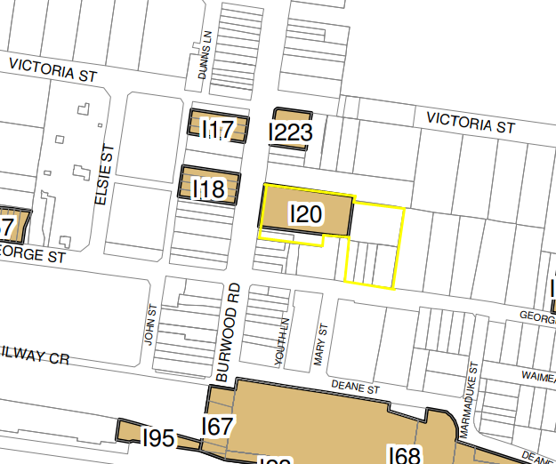
Figure 7: BLEP 2012 – Heritage Map.
6.1 Acid Sulfate Soils  Various requirements depending on ASS class | The site is identified as Class 5 Acid Sulfate Soils. The subject site is not located within 500m of Class 1, 2, 3 and 4 land.  The proposal, as amended, does not alter the assessment and recommendations of Report on Geotechnical Investigation and Waste Classification Assessment prepared by Douglas Partners submitted as part of the original application. Any detailed construction requirements will be addressed within the future detailed proposal.  An assessment of the potential impact of the proposal, as amended, on the heritage significance of the site and surrounding heritage items has been undertaken by GBA Heritage and is considered acceptable. | Yes
6.2 Flood Planning | The proposal, as amended, does not alter the assessment and recommendations of Civil Engineering Report prepared by TTW as part of the original application. The future detailed design will address the required freeboard for basement and building floor level entries. | Yes
6.3 Active Street Frontages | The proposal, as amended, continues to be designed to provide an active street frontage to Burwood Road, including:  - Retail/restaurant floorspace with covered awning and associated outdoor dining area at the ground level of Building 2  - Retention of the existing place of public worship and public gathering spaces, including heritage significant features. | N/A
6.5 Design Excellence in B2 and B4  (a) whether a high standard of architectural, landscape and urban design has been achieved (including in the materials used and in detailing appropriate to the location, building type and surrounding buildings),  (b) whether the form and external appearance of the proposed building, and ground level detailing, will significantly improve the quality and amenity of the public domain,  (c) how any streetscape and heritage issues have been addressed,  (d) whether the amenity of the surrounding area, including any view corridors, vistas or landmark locations, will be adversely affected,  (e) how traffic circulation and vehicular access will be addressed and whether the proposed development supports the provision of high quality pedestrian, cycle and service access,  (f) whether any adverse effect on pedestrian movement and experience will be avoided (and whether the public transport interchange as the focal point for pedestrian movement in the surrounding area will be reinforced and the ease of pedestrian access to and from that interchange will be facilitated),  (g) whether the development supports an integrated land use mix in Zones B2 and B4, including a diversity of public open spaces at the ground level, as well as the roof and other levels of buildings,  (h) how the bulk, mass, modulation, separation, setback and height of buildings have been addressed and whether they are appropriate in the context of existing and proposed buildings,  (i) whether a high standard of ecologically sustainable design (including low-energy or passive design) will be achieved and overshadowing, wind effects and reflectivity will be minimised. | The Architectural Design Report prepared by TURNER (and attached as Appendix A) demonstrates the way in which the concept proposal commits to the delivery of design excellence within the future detailed proposal. The concept proposal has been carefully considered to enable all relevant matters to be addressed in the detailed architectural design, including:  - The siting of the proposed new buildings has been carefully considered regarding the existing and likely future development within the surrounding area, including compatibility of the building height, scale, shadow impacts and the like.  - The proposed buildings have also been designed to respect and maintain the heritage significance of the existing Church and School Hall buildings, including the existing sightlines and streetscape.  - The amenity of the surrounding area has been addressed, including the potential view impacts, visual privacy and solar access and overshadowing impacts, including future compliance with the detailed requirements in SEPP 65 and the ADG.  - Traffic, access and car parking issues have been resolved, including the location of the proposed vehicle access and basement car park entry on George Street, as well as the through-site link that improves the existing permeability of the site and town centre connectivity  - Safe and direct access is provided to encourage pedestrian movements through the site and to Burwood railway station  - The proposed mixed-use development includes a variety of compatible land use activities with an active ground plane that complements the proposed uses and is compatible with the town centre, as well as aboveground communal open spaces that meet the needs of future residents  - The bulk, mass, modulation, separation, setbacks and height of buildings have been carefully considered within the context of the site and the locality, including both existing and proposed buildings.  - The proposed built form is considered entirely consistent and compatible with the transitioning built form within the town centre and will make a positive contribution to the streetscape and the city skyline  - The concept proposal has considered ecologically sustainable design principles, including building envelopes that will facilitate access to natural daylight and ventilation and the opportunity to minimise energy use.  - The future detailed proposal and associated DA for the construction of the buildings will further outline the way in which design excellence will be achieved through the selection of appropriate materials, detailing and the like. | Yes

Note 1 – Non-compliance with Clause 4.3 – Height of Buildings & Clause 4.6 Exception to Development Standards
Under the provisions of Clause 4.3 Height of Buildings contained in BLEP 2012 requires that for sites located in Area AA1, the maximum height of building is not to exceed 60m as shown in the Height of Building map and Figure 8 below.

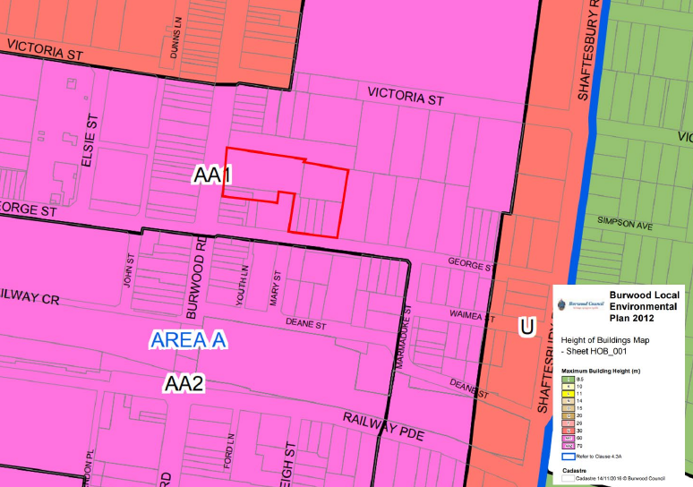
Figure 8: BLEP 2012 Height of Buildings Map Extract

The development proposes to construct 3 new buildings being, Building 1 – Tower, Building 2 – retail/restaurant/boarding house (student accommodation) and Building 3 – Ancillary Church Office and Gathering area. The heights of these buildings are as follows:

Building | Permitted Height | Proposed Height | Comply
Building 1 | 60m | 91.5m  (RL 105.45 – roof)  (RL 107.40 to top of parapet)  26 storeys | No – Clause 4.6 submitted, exceeds development standard by 31.28m or 52.5%.
Building 2 | 60m | 24.9m  (RL 40.70)  5 storeys | Yes
Building 3 | 60m | 5.33m  1.5 storeys | Yes

Clause 4.6 of the BLEP 2012 provides authority and procedures for consent authorities to consider, and where appropriate grant consent to, development even though the development would contravene a particular development standard. The objectives of Clause 4.6 are to provide an appropriate degree of flexibility in applying development standards, and to provide better outcomes for and from development by allowing flexibility. The provisions of Clause 4.6 may be applied to the maximum building height development standard of BLEP 2012 pursuant to Clause 4.6(6)&(8).

In accordance with Clause 4.6(3), for Council to consent to an exception to a development standard it must have considered a written request from the applicant that seeks to demonstrate that:

(a) that compliance with the development standard is unreasonable or unnecessary in the circumstances of the case, and
(b) that there are sufficient environmental planning grounds to justify contravening the development standard.”

Request to vary Maximum Height of Buildings Development Standard

The applicant has submitted a written variation (amended) request under Clause 4.6 (refer to Attachment A of this report).The submitted request presents an adequate justification that has regard to the objectives of the height limit standard in BLEP 2012, and the objectives of the B4 zone.

The applicant contends that the character and built form of the surrounding locality is transitioning to facilitate a range of high-density mixed-use developments with similar scale and density and provides the following table of nearby recently approved development:

Site | Description | Status
Burwood RSL site (bound by Deane Street, George Street, Shaftesbury Road and Marmaduke Street) | The site is located approximately 200m south of the subject site. The approved development has a maximum building height of 94.6mm, which was subject to a Clause 4.6 request. | Approved
28-34 Victoria Street, Burwood | The site is approximately 50m north-east of the subject site. A DA (2019.091) has been lodged for a mixed development with a maximum height of 100.98, which includes a variation of 40.98m. | To be determined by JRPP on 15 September 2020
42-60 Railway Parade, Burwood | A Gateway Determination has been issued for a site approximately 300m to the south west seeking to increase the maximum building height to 136m and 144m, subject to further design analysis and impact assessment. | Gateway Determination Issued.
29 George Street, Burwood | The immediately adjoining mixed use development to the east of the subject site comprises 19 storeys with a maximum height of 70.5m which equates to a 38.3% variation. | Approved
7 Deane Street, Burwood | The approved residential development has a maximum height of 70.8m. | Approved
9-15 Deane Street, Burwood | The approved mixed use development has a maximum height of 82.24m. | Approved
17 Deane Street, Burwood | The approved 24 storey building has a maximum height of 104.075RL which was subject to a Clause 4.6 request. | Approved
121-123 Burwood Road, Burwood | Council’s assessment informed the Sydney Eastern City Planning Panel’s approval for a 13.14% variation to the height control. | Approved
In addition to the above table, recently DA.2019.40 was approved by the Burwood Local Planning Panel (BLPP) for the construction of an additional 4 storeys to an approved 25 storey mixed use development at 1-3 Marmaduke Street, 7 Deane Street and No. 4 George Street – this building was approved with a 91.35m building height above ground level height.
The Clause 4.6 submission also addresses relevant case law concerning variations to development standards, whether non-compliance is reasonable and necessary in the circumstances of the case, the planning grounds to justify the contravention, and the public interest. Based on the request, the following reasons support approval of the departure from the development standard.
- The proposed development fully complies with the BHP control for all three building envelopes in accordance with clause 4.3A of BLEP 2012. It also fully complies with the maximum floorspace that can be achieved in accordance with clause 4.4A of BLEP 2012. The proposal seeks only to redistribute the permitted floorspace to the eastern part of site, allowing for retention of the existing church buildings and delivery of publicly accessible open space and through-site pedestrian connection from Burwood Road.

- The proposal will deliver a superior planning outcome compared to a complying scheme. The reduced height (and floorspace) of the proposed building envelopes along Burwood Road will deliver an improved streetscape. The proposed slender tower design for Building 1 and the reduced heights of Buildings 2 and 3 will reduce the potential overshadowing impacts on adjoining properties.

- The proposed development includes the delivery of a significant new public space, with an activated ground plane and improved pedestrian links that benefit from natural surveillance. The concept landscape design is inclusive and welcoming, including bespoke furniture that encourages its use by the local community. The allocation of the potential floorspace towards the rear of the site enables the delivery of this public space, while optimising the site opportunities and social benefits arising from the proposed mixed-use development.

- The proposed mixed-use development is compatible with the scale and character of existing and likely future development within the Burwood Town Centre Middle Ring. The height of Buildings 2 and 3 are compatible with the height of existing buildings along Burwood Road, including the BCUC building which is to be retained. Building 1 is to be located at the rear of the site and is generally consistent with similar mixed-use development proposals within the immediate locality that have been approved by Council and the Sydney Planning Panel.

- The proposed development is consistent with the built form outcomes expressed within the Burwood Development Control Plan (DCP) including: ‘to develop human-scale street environments and to facilitate higher density development while maintaining the existing character of street development fronting Burwood Road’.

- The reduced heights for Building 2 and 3 will create an active and human-scale development along the Burwood Road frontage. The increased building height for Building 1 will facilitate the allowable floorspace to be delivered on the less sensitive part of the site towards the east and away from the Burwood Road frontage.

- The proposed variation to the maximum height for Building 1 facilitates a taller, slender tower element which minimises the potential visual impacts by reducing the overall mass and building bulk. It also enables solar compliance to be achieved for existing and likely future developments in accordance with the Apartment Design Guide (ADG). Additionally, the tower provides two subtly defined zones that enable a transition between the emerging contemporary Burwood skyline (south) and heritage listed items located on site.

Officer comment:
It is accepted that the building height exceedance as proposed will not result in a development that is visually out of character and scale with what is reasonably anticipated in the town centre. In addition, the height exceedance in itself does not result in any unreasonable amenity impacts on the adjoining properties in comparison to a compliant scheme.

The assessment argues that the non-compliant height is acceptable in the circumstance as the building will provide both employment and various residential accommodation opportunities in a location that is well served by urban infrastructure. Insisting on strict compliance would not yield an improved building outcome. This assessment concurs with those arguments and the applicant has demonstrated that the proposed height of the building results in a building which is appropriate in terms of the urban design outcome.

The applicant contends:

“The proposed has been comprehensively assessed regarding its potential environmental impacts on the amenity of the adjoining areas. The slender tower design for Building 1 and the reduced heights for Buildings 2 and 3 will reduce the potential overshadowing impacts associated with a complying scheme. The commitment to design excellence and the future architectural design treatment will provide for an attractive built form that makes a positive contribution to the city skyline.

Further, the proposed height and design of the envelope for Building 1 enables the permitted floorspace to be better allocated across the site and protect more sensitive parts of the site. This includes maintaining the existing sightlines to the heritage listed buildings and a consistent streetscape along Burwood Road and the Burwood Town Centre.

It is reasonable and appropriate to vary the maximum building height to the extent proposed for the reasons detailed within this submission and as summarised below:

    - The proposal achieves the objectives of the development standard as provided in clause 4.3 of BLEP and is consistent with the objectives of development within the B4 Mixed Use Zone.
    - The proposal is compatible with the existing site context and is consistent with the desired future character of the site and locality.
    - The proposal provides an appropriate transition in building scale consistent with the approved height of immediately adjacent development and the evolving skyline approved and proposed for the Burwood CBD and the desired outcomes for the Burwood Road streetscape.
    - An alternate scheme which complied with the maximum building height standard would result in adverse environmental impacts, including reduced residential amenity for the site and surrounding developments.
    - The proposal will result in significant social and economic benefits, including the revitalisation of a significant landholding within the Burwood Town Centre and additional employment opportunities.
    - The proposal will deliver significant public benefits, including public open space, improved pedestrian connections and a range of community facilities.”

In accordance with Clause 4.6(4)(a)(i), the applicant’s written request is considered to have satisfactorily addressed the matters required by subclause (3) as the written request seeks to justify the contravention of the development standard by demonstrating:

  - that compliance with the development standard is unreasonable or unnecessary in the circumstances of the case; and
  - that there are sufficient environmental planning grounds to justify contravening the development standard.

It is considered that the proposed development will be in the public interest because it is consistent with the objectives of the maximum height standard and the objectives for development within B4 zone.

On this basis, the requirements of Clause 4.6(3) are satisfied, and the variation supported.

Note 2 – Clause 5.10 Heritage Conservation
Since the lodgement of the concept Development Application, it has undergone several design amendments in relation to heritage conservation and urban design assessment. A detailed list of the amendments made to the concept application initially lodged with Council up until the plans currently presented before the JRPP at their meeting of 15th September 2020 is provided below.

Initial Plan referral to Council’s Heritage Advisor - Initial Council Heritage Referral comments

- Crowding of the Church by the infill building to the north in terms of proximity and scale.
- Lack of a “Stabilisation Zone” to allow medium to long term protection of the sandstone fabric.
- It is considered that the Sandstone walls of the Church are the original to the first Church and should be graded as being of “Exceptional” value.
- It is considered that the Tower and Spire are of Landmark value and should be graded as being of “Exceptional” value and views to these elements be protected to a high degree.

- The proposed excess development above the permissible height of the Mixed Use Tower by some 30 meters is considered unacceptable. It adds to the heritage impacts in terms of bulk and scale far beyond what is anticipated in the Zoning and Planning Controls.

- The proposed height of the Student Accommodation Building would restrict views of the Church Tower and Spire to an unacceptable degree. It is considered that a reduction of 2 floors in height would be acceptable.
- Lack of a connecting passage through the site linking to Victoria Street via adjoining development passage.
- Access from proposed basement car park to the Church and to the Church Hall and Offices buildings are poorly resolved in terms of travel distance from available Lifts and for lack of cover.
On 16 August 2019 additional information submitted to Council addressing Heritage issues:
- Reduction of Building 3 to 5.33m and the highest point of the Church windows on the northern façade;
- Increasing the separation of Building 3 to the Church to 2.2m, maintaining the glazed wall that will enable visual and physical access to the northern Church wall; and
- Access to the proposed Church administration area from the Basement, which includes accessible access to the proposed gathering space, building amenities and Church within the built form.
A Statement of Heritage Impact and a Schedule of Conservation Works has been prepared by GBA Heritage the key findings are listed below:
- The significance of the Church and School Hall buildings and their contribution to the streetscape and the locality will be retained.
- All significant views to the Church and Hall will be retained. The existing open space to the south and west of the heritage items will be retained and enhanced with landscaping.
- The concept building envelope for Building 2 (south of the heritage items) will visibly defer to the Church and Hall buildings, be sympathetic in form and materiality and has been designed to enhance visual and physical access to the site and minimise impact on views of the Church steeple.
- The concept building envelope for Building 3 (north of the heritage items) has been design and located to be minimally visible from the public realm and will be setback from the front façade of the church to provide views to the northern facades of the heritage items through the glazed southern walls.
- The concept building envelope for Building 1 (east of the heritage items) has been designed to echo the verticality of the Church and its podium will be a simple façade form to avoid visually competing with or dominating the heritage items. the proposed high-rise building will have minimal additional visual or heritage impact on the subject site, considering the existing buildings and skyline to the east.
- Based on the existing high-rise buildings, the proposal will have no adverse heritage impact on any items in the vicinity.
- The proposed development is consistent with the heritage requirements and guidelines contained within the LEP and DCP.
- Inspections are to be carried out by specialist contractors as part of the conservation process; this would include further examination of the fabric as requested by Council.
- The sandstone walls of the Church have been amended in the Schedule of Conservation Works to be identified as an ‘exceptional’ contribution to significance.
- Lot 1 on DP 795259 forms the boundary of the current heritage curtilage, and an additional visual curtilage (with regard to the tower and spire) is adopted to safeguard existing views of the Church from the public realm.
- The amended proposal significantly reduces any perceived crowding of the Church and encourages public and church visitor’s appreciation of the heritage listed items.
- The Streetscape Analysis prepared by Turners Studios identifies the significant views to the Church and spire from the public realm, and demonstrates that the view of the top of spire is maintained within the DCP required visibility cones, and a minor loss is only experienced at a distance of 100m from the site on Burwood Road. Given the likely future development of sites to the north and south, it is unlikely that this view would be retained in the future. Accordingly the height of Building 2 is supported as originally proposed.
- Should any unexpected relics be disturbed during the excavation of the site, these relics must be managed in accordance with the archaeological provisions of the NSW Heritage Act.
- Each of the above recommendations could be included as conditions of consent, including demonstration of compliance as part of the future detailed DA(s).
- GBA Heritage recommends the application for approval, pending the implementation of the recommended mitigation measures for site landscaping to avoid obstructing views, conservation of the stone boundary wall and selection of appropriate building materials for Building 2. Each of these matters can be imposed as conditions of consent and addressed within the future detailed DA(s).
- An amended Schedule of Conservation Works has also been prepared and is submitted with the Concept DA. The detailed works outlined within the schedule, such as the identification of an appropriate stabilisation zone, will also be incorporated into the future detailed proposal(s) and associated DA(s).
The amended plans were referred to Council’s Heritage Advisor for further assessment, the response received on 29 August 2019:
Analysis of the fabric
A more detailed analysis of the fabric of the Church and School Hall have now been provided within the Statement of Heritage Impact and now forms a sound basis for decisions regarding necessary conservation works to the fabric.

The Schedule of Conservation Works has also undergone some revision and sets out a methodology for management of the conservation works entailed in the project.
This relies to a large extent on the continued involvement of GBA as heritage consultants which would be a normal condition required by Council in such a project.

It would be necessary to set out by some additional form of documentation a more precise quantification of the works or a process by which Council may be assured of what the outcome of the Conservation programme would be in terms of preserving both fabric and significance.

Some further discussion with the applicant and their heritage consultants would be the most productive method of determining how Council may be able to set out its requirement that conservation work be completed or substantially completed before occupation of the works entailed in the overall project.
Significance of Sandstone Walls
The extent of survival of the original sandstone walls is now clarified but not fully quantified; however the issue now seems capable of resolution within the overall conservation programme.
Gradings of Significance
The view analysis provides some recognition of the contribution of the spire to the townscape. There is some question as to whether the detailed design of Building 3 in particular provides the best outcome for visibility of the spire from the approach along Burwood Road from the south.
Curtilage Analysis
A curtilage has now been proposed relating to the original allotment on which the church is situated. Relationships with the other buildings 1 & 3 may be inferred from this definition.

It would, however form a reasonable basis for ongoing management of the Item assuming the project proceeds to approval and fruition.

The viewlines defined in the curtilage diagrams and view analysis represent a conservative approach but the sequential 3D views of the church and spire from several points along Burwood Road provide a useful assessment tool, particularly in relation to the configuration and envelope of Building 3 which is discussed further below.
Crowding of the Church Building
Concerns were previously raised that Building 2, the Infill for Church Foyer / Hall / Offices would “crowd” the Church Building and preclude separation that is necessary for long term natural stabilization of the sandstone building. The scale has been adjusted to provide a building that relates more harmoniously to the Church. This is at some cost as the lower floor is now set down as a lower ground floor. The linkage to the existing entry porch could be further refined in detail to permit a better view of the apex of its gable, rather than covering it but this is a refinement easily managed in the design development process.

Overall the relationship with the Church and the design with an extensive section of glazed roof over the foyer area represent a refinement of the concept with aesthetic benefits.

There is still some question as to the safeguards needed in building within the zone of influence of the Church’s footings, but there is sufficient separation to suggest that, with appropriate monitoring of vibration and other engineering input, the significant fabric could be protected in the construction phase.

Treatment of the interstitial zone between the Church and Building 2 has some residual issues, but the lowering of the new building now suggests, with the assumption of site drainage being incorporated that drainage can be controlled to prevent uptake of ground moisture through the sandstone walls.

Some design ingenuity may be required to address the blank southern wall of the neighbouring building to the north along the entry line to the relocated Church entry.
Suggestions for its treatment may include Church Identifying Signage, changing display area, general landscaping, “green wall” treatment or a combination of these, of course subject to DA approval.
A “Stabilisation Zone”
Appears to have been incorporated which would assist management of the moisture at the base of the sandstone walls of both the Church and the Church Hall although the Church Hall appears to have been more closely surrounded.
Scale and Mass of Mixed Use Tower
There has some attempt to mitigate the impact of the mass and scale of the podium but little relief from the canyon wall effect of the serrated tower. While the treatment of the podium element of Building 1 is of benefit in providing a more human scale to the pedestrian areas of the Church footway, the relative height of the tower virtually negates the potential benefits of this generous gesture to public space.

That is not to say that the base of a large building cannot be made a lively and stimulating urban space as is the case when we think of a mediaeval city built up to the castle or city walls. The scale difference in those cases is more like a ratio of 3:1 or 4:1 of the height of the city wall to the width of the pedestrian way. In this case the tower element adopts an over-monumental scale which makes the pedestrian realm into a virtual Lilliput or scale model village.

This appears to be a fatal flaw in the concept, the idea that the tower of Building 1 somehow “disappears” or for some reason does not dominate is a false one, and it clearly does. It is literally a skyscraper and the notion that there are other buildings of comparable scale nearby is simply not so. This would be the tallest and, by its linear plan, the most dividing building form in Burwood. The only similar building form is the building along Railway Parade which at least has the excuse of adopting such a linear city wall form in response to a linear site along the margin of the railway line.

While there is some benefit to the separation between Building 2 and the remaining lower scale components of the project the overall disparity in scale is an indication of a mismatch of both objectives and physical forms. There is little gained if a human scaled walkway between Church and other attractive buildings becomes an overshadowed and windswept canyon.

In this case, the proposal is for a building that exceeds the height permitted by the LEP Height Control map. Such additional height adds directly to the bulk, scale and overshadowing of the Heritage Item and adds considerably to the impacts that would result from a development that complies with the permissible height control.

The Height of the proposed Tower is not supported in terms of its heritage impacts. Arguments pointing to adjoining development and other recent developments of towers do not form a precedent in this regard. The argument that this development should be permitted 7 or 8 additional storeys above the Height Limit Control when its bulk and scale are considerable not supported.

It would result in building of an additional 30 meters in height above the permissible limit of 60 meters ( a total height of 90 meters).

An additional 30 meters in height will not “disappear” above the podium and the effects from overshadowing alone on the setting of the Church Item would be highly detrimental if built at the proposed height.

As designed the proposed Tower would dominate not only the immediate setting of the Heritage Item but would impact on the Burwood Road Streetscape.

The building should observe the stipulated height control as a maximum height.
Scale and Mass of Student Accommodation Building
The height of the proposed Student Accommodation Building has been reduced mainly by using part of the mezzanine / atrium level now for 14 student rooms. While this is beneficial, the height of the upper floors remains a visual challenge to the primacy of the Spire as a legible emblem within the street and townscape.

Crowding of such an element is not unusual within a developing CBD context. The detailed view analysis suggests however, that the views of the spire from the south are in part curtailed by the buildings immediately to the south of Building 3.

This opens up the possibility of further reconfiguration of Building 3 by duplicating the plan of the Upper Ground level on Level 1 for 14 rooms and reducing the height of the 8 bedroom tower section by one level.

Such an approach would not have marked effects on the visibility of the spire from along Burwood Road but would have the benefit of reinforcing the primacy of the Spire as a landmark element within the development, at least in relation to its neighbouring building to the south, building 3.

The present height of Building 3 is not supported, however the form appears capable of providing the required number of student bedrooms within a lower envelope. The design with a curved end is otherwise appropriate, particularly given the staggering of the window openings but the irregular and arbitrary mismatch of the curve of the upper tower versus the lover colonnaded form is incongruous. (The upper curve in plan appears elliptical versus the lower which is a rounding of a chamfered form in plan). A better resolution is both possible and desirable.

The 3D views provided now permit understating of a pedestrian’s point of view as discussed above. Further manipulation of the form of Building 3 would have appreciable benefits in preserving the landmark qualities of the Tower and Spire.
Connecting Passage Through Site to Victoria Road
The proposed passage / connection through the site between Burwood Road to connect with the passage on the eastern side of Building 1 relies on a curious set of double shutters and, while ingenious, does not provide a “well located, safe and attractive pedestrian link between existing streets”. The location is probably a correct one, but it fails to meet the objectives or satisfy the provisions of BDCP 3.9.3 and cannot be accepted as a valid “Thru Link” either for pedestrian or the articulated vehicles attending the delivery dock through the double shutter doors on either side of the purported pedestrian link.
Lack of Vertical Access to Church
The inclusion new of a lift and a means of accessing this from the associated car parking in the basements of Building 1 have resolved a functional issue and is acceptable, subject to some more detailed reviews in Design Development.
Amended plans were provided to council, these plans were referred to Council’s external heritage consultant City Plan who provided the following comments on 28 July 2020:
Overview
As detailed in the background section above the application has undergone several amendments in consultation with the Council and this is the final step before it is referred to the Planning Panel. Therefore, no comments have been provided in relation to the existing physical curtilage around the Church building nor on the general bulk and scale of Building 2 noting that the heritage listing includes only part of the site identified as 134A Burwood Road (LOT 1 of DP 795259), which does not cover the southern portion that is used for car parking. It would have been a desirable outcome to maintain the existing open setting of the site 134A Burwood Road as a whole but the current layout has already been agreed between the Council's planning and heritage consultants and the Applicant.
Church Administration Building - Building 3:
- Subject to review, issues are in-principally resolved and the design is support with conditions of consent
- Support the reduction of the height of the building throughout the DA process
- Interesting problem that church has been extended to west so entry from the porches
- Blank wall of adjoining building could provide opportunity display of the heritage significance

COMMENTS:
The comments in relation to Building 3 are generally supported noting the further amendment to the western façade fronting Burwood to form a gabled facade matching the pitches of the Church’s main building and northern porch. Given consideration to the setback of two-bays and lightweight nature of the proposed Building 3 the impact on the Church's prominence from northern approaches and direct views is considered negligible and acceptable. It is important at the detailed design stage to carefully resolve the junctions between the new structure and the existing Church building and the Hall behind. It is also important to maintain a clear visual to the northern elevation of the Church building and the Hall from the gathering space of the new building so that the appreciation of the building's classical architecture is increased.

Use of the blanks wall for heritage interpretation is strongly supported and details can be dealt with a the detailed design stage through conditions of consent.

Similarly, basement of Building 3 will need to be carefully considered with mitigation measures embedded into the pre-construction dilapidation survey and vibration monitoring by suitably qualified heritage consultant and structural engineer. Conditions of consent should be included in this regard as part of the detailed design stage.
Student Accommodation Building - Building 2
- Subject to review, issues of building envelope are in-principally resolved as impact has been reduced and the design is support with conditions of consent
- Sequence of views showed Building 2 obscured from certain points of view but height could potentially be further reduced to better respond to church building
- Solid-to-height ratio supported - better variety including the façade curvature from street – Council needs additional time to review and confirm position

COMMENTS:
The comments in relation to Building 3 are generally supported noting the further setback of the seventh storey (top floor) from the western facade. It is noted; however, the height of the building remains the same as previous scheme. The setback of the seventh level (level 5) further from the Burwood Street façade of the student accommodation building partially mitigate and reduces the bulk of Building 2 from the streetscape approaches and in its inter-relation with the church square. This may allow further airspace to the immediate curtilage of the Church building and the steeple when viewed directly from Burwood Road.

As noted in the previous comments by Colin Israel that crowding of such an element is not unusual within a developing CBD context. The detailed view analysis suggests however, that the views of the spire from the south are in part curtailed by the buildings immediately to the south of Building 2. While the views from the southern approaches along Burwood Road to the top of the steeple/spire will be blocked by the proposed Building 2, the close views within the identified visual curtilage from the western corner of George Street to the steeple will be largely maintained. The views to the Church and the steeple from the northern approached along Burwood Road will be maintained in their current exposure.

It is however, unclear whether the awning of Building 2, which is a horizontal element that takes one's attention at public domain level relates to any horizontal element of the Church or the steeple. It is recommended that either the sill level of the windows on the Church tower or the splayed top of the first buttress is taken as a height for the awning to allow a better relationship with the heritage item and the adjoining show awnings to the south.

Use of the light colour brick finish is supported to relate to the sandstone finishes of the Church. In the detailed design stage, consideration should be given to the transparent nature of the ground floor retail spaces to allow for an active use of the pedestrian pathway and the public domain in reflection of the current a more open curtilage around the southern side of the Church.
Tower Building - Building 1
- Acknowledge Concept Plan application but very horizontal expression to building
- Benefit to dividing tower and curved end opens up sky view behind tower which seems to be an advantage
- Opportunity to create curtain behind church – this can be achieved with a façade treatment in detailed DA
- Pedestrian level elements could succeed particularly the brick material against the Church, however, still concerned about relative bulk of tower and loss of sky behind church
- Views from Burwood Road are significant as heart of Burwood
- Like curved tower to break up scale of tower - could step tower to provide advantage - query benefits of slot and impacts on steeple and its verticality
- Concerns with small remnant buildings being over-towered by big buildings in close proximity
- Do not include picture 3 as an example
- Acknowledge urban design parameters but heritage preference would be to have higher four storey podium with blank wall behind the church;
- Consider drainage and stonework before you build it in - not museum piece bur proper attention.

COMMENTS:
The comments provided above in particular the concerns raised in relation to the bulk of the tower and the loss of the sky behind the church are concurred.

It is acknowledged that there have been further amendments to the design of the tower (Building 1) since the January 2020 meeting as detailed in the SOHI by GBA Heritage (February 2020) quoted below:

The proposed building comprises a mixed commercial/administrative podium and a residential tower set back above it. The proposed changes are as follows:

- The tower’s mass has been articulated into two primary masses, separated by a vertical recess.
- The eastern facade of the southern section of the tower has been angled towards the south-east. ▪ The podium height has been reduced.
- The podium form has been simplified.
- The envisaged design of the podium facades (to be finalised in Stage Two) has been altered as follows:
- The ‘green wall’ section has been deleted.
- The solid to void ratio has been increased to more closely align with that of Building 2.
- The cladding is intended to be masonry, similar to that of Building 2.

Articulation of the tower into two masses, and the angling of the eastern facade of one section, has the effect of reducing both the apparent bulk and mass of the building and the area of surface facing Burwood Road, thus presenting less competition with the Church as seen from Burwood Road, and with the Church and Hall as seen from inside the site. The backdrop of the Church and its spire as seen from Burwood Road is now the less bulky, more vertically proportioned northern section of the tower, which, together with the recess between the two sections, emphasises and sympathises with the verticality of the Church spire.

Further amendments have improved the overall presentation and articulation of the tower building; however, the bulk especially the north-western wing behind the Church steeple remains as an over dominating element at the backdrop. The simplified façade void and solid articulation makes the tower being capable of creating a curtain behind the Church and steeple but as a proportion to the scale of the Church tower and steeple needs to be further considered in terms of articulation. The three times proportional height of the Church tower coincides approximately with the height of the tower at 29 George Street, which would make the proposed tower (Building 1) more compatible with the Church tower as a background. This would also aid in a more compatible and proportional height to width ratio between the new Building 1 and the pedestrian way as noted in the previous heritage comments.

At a minimum, it is suggested that the height of the north-western wing of the proposed tower (building 1) be reduced to the height of the 29 George Street for an acceptable and more articulated tower form within the immediate visual curtilage of the heritage item. The argument of not fully achieving the allowable floor space as part of the development hence increasing the height of the tower (91.5m high) further than the neighbouring previously approved or under construction towers (the highest being 82.24m at 11-15 Deane Street, which is in a maximum 70m height zone) is not justified. The Uniting Church building and the Church Hall will be dwarfed by the proposed height of Building 1 in addition to the crowded nature of the proposed Building 2 and 3 at either side of the Church building. There are no other buildings in surrounding properties at Burwood Town centre and within the same zoning that is as high as the proposed development.

The width of the slot-cut between the two primary mass of the tower (Building 1) needs to be further considered to ensure it does not become a wind tunnel that may affect the air circulation between the buildings and the public domain. This could be a matter for an engineering solution, but it has potential to create some issues to the lower buildings around it in particular the sandstone structure of the Church and the Hall
Adaptive Reuse of the Church hall:
Adaptive reuse of the Church Hall for a potential restaurant is acceptable provided that further details are included on the extent of the intervention and changes to the interior of the Hall, and if any to its exterior. Further assessment could not be made at this stage.

Schedule of Conservation Works
The amended schedule of conservation works provides sufficient level of information to guide the conservation works to the Church and Church Hall. As noted in the previous heritage comments final confirmation of the required schedule of works and supervision by suitably qualified heritage consultant is essential. This could be achieved by conditions of consent for the engagement of a heritage consultant for the duration of the detailed design and constructions stage, requiring a Temporary Protection Plan and Vibration Monitoring measures prior to the issue of a Construction Certificate, and a sign-off statement report by the engaged project heritage consultant detailed the works carried out during the conservations and the measures taken as well as the decisions on any exposed fabric/detailing.

SUMMARY
In summary, the further amendments to the concept design of the proposed development is partially supported in relation to the heritage matters provided that the height, bulk and mass of the tower (building 1) is further considered as suggested above. The tower adjoins as an important heritage item that has prominence within the townscape of Burwood providing a church square that will be reduced by the introduction of Building 3 to the north and Building 2 to the south through extended footprint into the current car park space. It is acknowledged that the Project Team for the application has made considerable effort in response to the Council's concerns in relation to heritage and planning since 2018, which reduced the issues to be considered in the final concept design stage with the bulk and height of the tower (Building 1) being the primary heritage concern that could not be resolved as a condition of consent.

Any future consent for the subject development should be managed by inclusion of conditions for the following documentation in addition to the Schedule of Conservation Works and above noted recommendations for the protection of the heritage significance of the Uniting Church building and the Hall:
▪ A Temporary Protection Plan incorporating dilapidation survey, vibration monitoring, measures for
the protection of significant fabric.
▪ Photographic Archival Recording
▪ Heritage Interpretation Strategy

On 20 August 2020 amended plans and documentation were submitted to Council addressing the above heritage matters raised by CityPlan. Included in this documentation was a Supplementary Statement of Heritage Impact prepared by GBA Heritage dated 13 August 2020 which addresses the above matters as follows:
Overview
CityPlan’s letter states as follows:
It is... unclear whether the awning of Building 2, which is a horizontal element that takes one’s attention at public domain level relates to any horizontal element of the Church or the steeple. It is recommended that either the sill level of the windows on the Church tower or the splayed top of the first buttress is taken as a height for the awning to allow a better relationship with the heritage item and the adjoining show awnings to the south.
The proposal has been modified so that the awning aligns with the sill of the spire window. This has a positive heritage impact compared to the earlier proposal as it creates greater visual sympathy with the Church. We understand that CityPlan has confirmed to Council that this will allay their concerns on this matter.
2.2.1 The ‘slot’
CityPlan’s letter states as follows:
The width of the slot-cut between the two primary mass of the tower (Building 1) needs to be further considered to ensure it does not become a wind tunnel that may affect the air circulation between the buildings and the public domain. This could be a matter for an engineering solution, but it has potential to create some issues to the lower buildings around it in particular the sandstone structure of the Church and the Hall.
The ‘slot’ has now been greatly reduced in depth. This slot is part of the articulation of the tower massing, intended to split the mass into two more vertical elements as a means of achieving greater sympathy with the Church and spire, and generally reducing the apparent mass behind the heritage building. The depth of the slot therefore need only be sufficient to create this visual perception of a division into two masses and could probably be achieved with a depth of a metre or so. Thus the heritage impact of the modified slot is acceptable.
Our understanding is that CityPLan has confirmed to Council that this is an appropriate solution of this concern and can be further detailed at DA stage as an engineered solution.
2.2.2 Height of the north section
CityPlan’s letter states:
The three times proportional height of the Church tower coincides approximately with the height of the tower at 29 George Street, which would make the proposed tower (Building 1) more compatible with the Church tower as a background. This would also aid in a more compatible and proportional height to width ratio between the new Building 1 and the pedestrian way as noted in the previous heritage comments. At a minimum, it is suggested that the height of the north-western wing of the proposed tower (Building 1) be reduced to the height of the 29 George Street for an acceptable and more articulated tower form within the immediate visual curtilage of the heritage item.
It has been clarified that ‘the north-western wing’ refers to the whole section north of the ‘slot’, which we refer to herein as ‘the north section’ of the tower. This section of the tower has been reduced in height to that of 29 George Street.
2.2.3 Footprint of the north section
A further modification to the tower design is proposed, namely to realign the ‘slot’ with the passage between the
Church and Building 2, creating a ‘north section’ of smaller footprint than in the previous proposal. This would have the following positive heritage impacts compared to the earlier proposal:
• Even at the reduced height, the north section of the tower, standing behind the Church and spire, would be ‘slimmer’ and more vertical in proportion, providing a more sympathetic mass as a backdrop when seen
from Burwood Road.
• The south section of the tower is angled to face south-west rather than west, so as to reduce the mass behind the Church and to present less mass directly to Burwood Road. Realigning the ‘slot’ will place more mass in the south section, decreasing the mass directly facing Burwood Road and decreasing the visual
impact on the heritage items

• The site would be divided more clearly into two subtly defined zones:
• a ‘heritage’ northern zone including both heritage buildings, the low-scale Building 3 and the slimmer
north section of the tower as a backdrop; and
• a ‘contemporary’ southern zone including Building 2, the south section of the tower and the other tall
buildings in George Street.
Thus the proposed realignment of the ‘slot’ and the modified footprint of the north section of the tower will have a positive heritage impact compared to the earlier proposal. Our understanding is that CityPlan has confirmed to Council that this is acceptable from a heritage perspective.

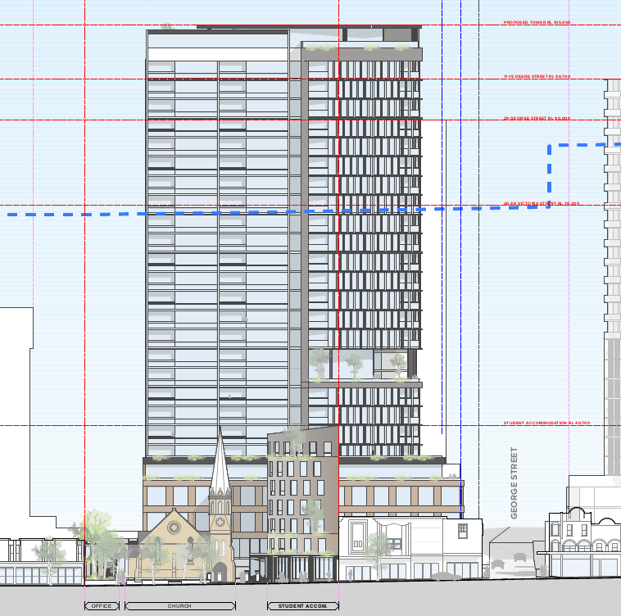
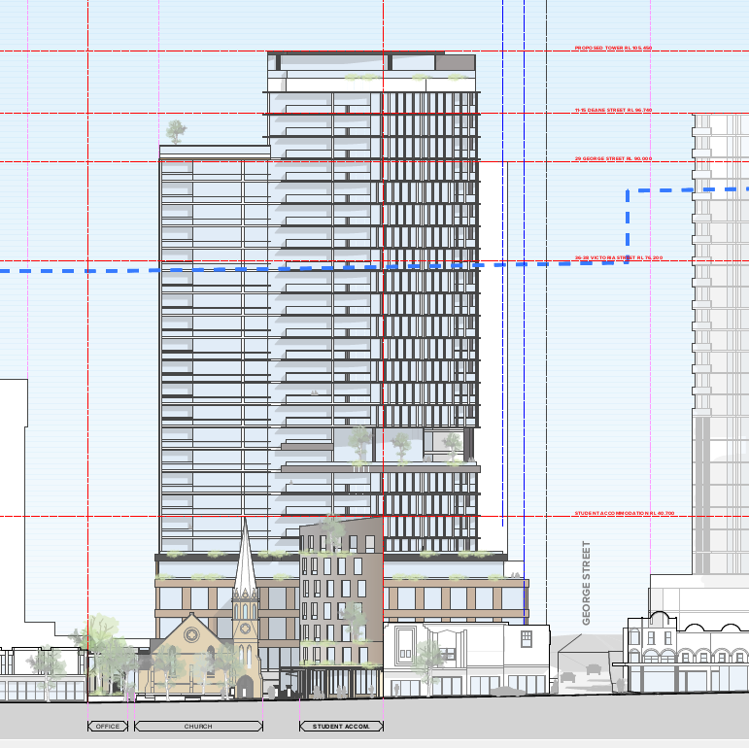

Figures 9 & 10: Figure 8 (left) Initial Design of Towner, Figure 9 (right) Amended Tower with deletion of 5 storeys to northern portion of tower. Courtesy: TURNER
As identified in the above Figures 9 & 10, significant amendments have been made to Building 1 (Tower Building) in accordance with the advice provided by Council’s Heritage Advisor and external Heritage consultant, Cityplan, in that 5 storeys of the northern portion of Building 1 have been deleted, and the building re-oriented, to provide a “stepping down” of the built form for the component of the building that is closest to the Burwood Uniting Church.

In conjunction with the several other amendments made to the concept development as listed in the above table, the amended concept design submitted to Council on 20 August 2020 is now considered to have appropriately addressed the outstanding heritage matters. In this regard, it was advised by Council’s Heritage Advisor that further review to Council’s external heritage consultant CityPlan was not considered warranted. Council’s Heritage Advisor has recommended conditions of consent be imposed upon the development in relation to ensuring that any work (involved with any future Development Applications) is undertaken in accordance with the Schedule of Conservation works submitted with the application (as referenced in Condition 1 of the attached schedule) and Burwood Council’s Public Art Strategy. These conditions have been imposed. In this regard, the proposed concept Development Application is considered to have satisfied the provisions of Clause 5.10 of BLEP 2012.

Burwood Development Control Plan 2013
The Burwood Development Control Plan 2013 (BDCP) applies to the proposed development. A summary of the assessment of the application against the relevant planning controls and objectives within BDCP is shown in Table 4 below.

Table 4: Assessment of the proposed development against Burwood DCP 2013
Provision | Assessment of Proposal | Compliance
Part 2 Site and Environmental Planning
2.2 General Site Analysis  - To be provided with a Development Application. | A site analysis has been prepared by TURNER and accompanies the application. | Yes
2.3 Views and Vistas  - Development applications must identify existing views and vistas significant to the proposal, assess the impacts of the development and demonstrate how significant views and vistas area to be protected and enhanced;  - Developments must have particular regard to high quality and priority views and vistas identified in other parts of this DCP, e.g. In relation to heritage items and heritage conservation areas. | The proposed development adopts appropriate front, rear and side setbacks. The scale of the proposal is reasonably expected in light of the controls that apply to the site, being compliant with FSR and building height plane controls under the LEP. As such, it is not considered that the development will give rise to any unacceptable view impacts on adjoining properties or nearby public spaces.  In terms of priority views, view analysis has been undertaken by the applicant in relation to nearby heritage items. The proposed development will not prejudice the setting of heritage items in the vicinity, particularly the setting of the “Congregational (Uniting) Church and Church Hall” at No. 134A Burwood Road, Burwood. Further, it is noted that the heritage items at No. 9 and 11 George Street have been approved for redevelopment (DA.2016.98), including an 18 storey tower above. This will block views from those heritage listed dwellings to the proposed development. | Yes
2.4 Streetscapes  - Development Applications must identify streetscape characteristics, assess the impacts of the development and demonstrate how significant streetscape qualities are to be protected and enhanced;  - Development Applications must demonstrate how building design, location and landscaping will encourage the protection and enhancements of streetscape;  - Development must have particular regard to high quality streetscapes identified in other parts of this DCP e.g. in relation to heritage items and conservation areas | The appearance of the proposed building is considered to be compatible with the emerging character of the streetscape and wider Burwood Town Centre Precinct, where a number of sites have been approved or are currently being redeveloped for high rise mixed use developments.  The streetscape is undergoing, or expected to experience, significant transformation in terms of built form and urban context. In this regard, the proposal is consistent with the anticipated future character of the area and will therefore enhance the streetscape.  The development will not adversely impact on the setting of nearby heritage items, as discussed in the LEP compliance table above. | Yes
Part 3 Development in Centres and Corridors
3.2.1 Building Design  O1 To ensure that new buildings:  - Represent architectural and urban design excellence.  - Provide cohesive and visually interesting building appearance.  - Respond to surrounding notable buildings and enhances the streetscape.  - Integrate roof design with the building character and enhances the skyline.  - Encourage rooftop gardens and planting on structures that enhance the quality and amenity of open space. | The proposal as amended, includes a commitment to design excellence, including:  - The proposed buildings have been carefully located and designed to enhance the quality and amenity of the public domain, including active street frontages, outdoor dining and through- site connection  - The proposed mixed-use development responds positively to the environment and context, including retention and preservation of the heritage significance of the existing buildings and sightlines to and from the public domain  - The building envelopes have been designed to respond to the existing, approved and proposed buildings within the surrounding locality, including solar access and overshadowing impacts, visual privacy and the like.  The future DA(s) will demonstrate the way in which this commitment will be implemented and achieved in accordance with the DCP. | Yes
3.2.2 Materials and Finishes
O1 To ensure that the use of superior quality external materials and finishes:  - Contributes to architectural and urban design excellence.  - Provides cohesive and visually interesting building appearance.  - Responds to surrounding notable buildings and enhances the streetscape.  - Provides longevity in external materials and finishes that are of superior quality. | The proposed materials, modulation and façade design, ensure the street elevations are well articulated and will have a positive visual impact on the streetscape and is compatible with the character of development envisaged in the Burwood Town Centre. | Yes
3.2.3 Lighting and Signage
O1 To ensure that that building lighting and signage:  - Contribute to architectural and urban design excellence.  - Provide cohesive and visually interesting building appearance. | Lighting and signage details have not been provided as part of the subject DA. A condition of consent is recommended specifying details of lighting to be provided to ensure consistency with the relevant BDCP provisions, including for public domain lighting. | Yes, subject to condition.
3.2.4 Street-Front Activities and Building Access  O1 To encourage pedestrian safety, visual interest and activity at street level.  O2 To promote street front activities, especially along streets of high pedestrian use.  O3 To create building entrances that are safe and contribute positively to the streetscape and building façade design. | The proposal, as amended, continues to be designed to comply with the relevant setbacks for Burwood Road and George Street. The future detailed design and associated DAs will demonstrate compliance with the DCP controls | Yes
3.2.5 Subdivision and Car Parking Spaces | N/A – no subdivision proposed. | N/A
3.2.6 Site Isolation  P1 The creation of isolated sites is discouraged. | The proposal will not isolate any sites as the adjoining sites have sufficient size and dimensions for future redevelopment. | Yes
3.2.7 Residential Flat Buildings and Shop Top Housing  P1 For any shop top housing, there is no numerical relationship between the number of dwellings and the ground floor retail or business premises. | The proposal includes non-residential uses, including commercial (office) tenancies, restaurants, a child care centre and medical centre. | Yes
3.2.8 Apartment Mix and Minimum Dwelling Sizes | The proposal provides for 124 apartments containing a mixture of one, two and three bedroom apartments as follows:  - 15 x 1 bedroom (12.1%);  - 97 x 2 bedroom(78.2%); and  - 12 x 3 bedroom (9.6%). | Yes
P1 Residential development in excess of 20 dwellings must provide a mix of dwellings containing one, two or more bedrooms.
3.2.11 Ceiling Height  P1 Development must provide the following minimum ceiling heights. Dimensions are expressed from finished floor levels to finished ceiling levels:  - Ground level of all development (commercial and residential): 3.3 metres.  - Non-residential floors above ground level: 3.0 metres.  - Residential floors above ground level: 2.7 metres for habitable rooms and 2.4 metres for non-habitable rooms. | The proposed development complies with the minimum ceiling heights, with all non-residential floors in the podium having ceiling heights in excess of 3.3m and residential floors above having ceiling heights of at least 2.7m. | Yes
3.2.14 Visual and Acoustic Privacy  O1 To provide adequate amenity. | Generally compliant building separation is provided in accordance with the ADG. Conditions of consent are recommended in relation to privacy treatments to the eastern side of the podium to ensure that neighbouring privacy is protected. | Yes, subject to condition
3.2.16 Lobbies and Internal Circulation – All Development  O1 To provide communal spaces which contribute to the overall design, experience and performance of the development. | Residential and non-residential lobbies and lift cores have been separated to avoid conflicts and enhance security. Lobbies and internal circulation areas are provided with windows for natural lighting and ventilation. Corridors are at least 2m wide. | Yes
3.2.18 Safety and Security  O1 To ensure development is safe and secure for occupant’s visitors and other users at all times. | The development includes extensive activation at street level and above, promoting passive surveillance. Residential and non-residential lobbies and car parking areas will be separated and secure. | Yes
3.2.19 Access and Mobility
O1 To ensure development is designed to facilitate access by the whole community including those with mobility impairment.  P6 At least 10% of dwellings in a development must be provided as adaptable housing to Adaptable House Class A or B standard to cater for ageing in place and mobility impaired residents, in accordance with AS 4299: Adaptable Housing. | Equitable access is provided to the development, including main residential and non-residential entry points and to all basement levels.  Adaptable housing: the future development application will be designed to comply with Control P6. | Yes  Yes
P7 At least one car parking space must be provided and allocated to each dwelling required to be provided as accessible or adaptable housing under this Section and the car parking space must be accessible in accordance with the provisions of AS 1428.2 to facilitate automatic vehicular wheelchair loading and unloading. | Accessible car spaces:  the future development application will be designed to comply with Control P7. | Yes
P9 For development providing between 80 or more dwellings, one accessible visitor car parking space must be provided on site at the rate of one per each 60 dwellings or part of. The spaces must be accessible in accordance with the provisions of AS 1428.2 to facilitate automatic vehicular wheelchair loading and unloading. | Accessible visitor’s car spaces:  the future development application will be designed to comply with Control P9. | Yes
3.3 Area Based Controls – Burwood Town Centre and Burwood Road North
3.3.1 Burwood Town Centre
3.3.1 Burwood Town Centre  P1 The height of buildings on land within the BTC is not to project above the BHP as identified in Clause 4.3A and on the map marked - “Building Height Plane Map in the BLEP 2012. | The proposed development has a maximum height that is below the BHP that affects the site. | Yes
3.3.2 Burwood Town Centre Areas – Commercial Core and Middle Ring Areas
Podium Height  P1 Burwood Road: Maximum 13m; George Street: Maximum 15m | The proposal, as amended, complies with the following podium heights:  • Burwood Road: 8.5 metres  George Street 15m | Yes
Street Front Setbacks
Burwood Road: zero setback  • George Street: 3 metre  setback | The proposal, as amended, has been designed to comply with the relevant setbacks for Burwood Road and George Street | Yes
Secondary Setbacks
Along Burwood Road:  The development above 13m is to be setback a minimum of 8m  Along George Street:  The development above 15m is to be setback a minimum of 6m | The proposal, as amended, has been designed to comply with the relevant setbacks for Burwood Road and George Street. The future detailed design and associated DAs will demonstrate compliance with the DCP controls. | Yes
Side and Rear Setbacks, Building Separation/Frontage Overview
ADG separations applicable | Refer to ADG building separations section of this report. The proposal is consistent with the ADG objectives for building separation. | On Merit
Communal Open Space
Podium areas are required to be made accessible as communal open space.  Landscaping is required to be provided within communal open space. This landscaping must have a minimum of 0.6m soil depth for at least 50% of the area | The proposal, as amended, includes communal open spaces on the upper levels of the residential apartment and student housing buildings. The future detailed design and associated DAs will demonstrate compliance with the DCP controls | Yes  Yes  Yes
Part 3.7 Transport and Parking in Centres and Corridors
3.7.2 Burwood Town Centre and Strathfield Town Centre
Basic parking requirement:  Development in the B4 zone in the Burwood and Strathfield Town Centres must provide parking spaces on site for each proposed land use in accordance with Table 2. | The proposal, as amended, includes a revised Traffic and Parking Impact Assessment prepared by TTP&A. This confirms the proposed traffic generation, vehicle access and on-site car parking can accommodate the land use activities proposed within the Concept DA.  The future detailed DAs will address the compliance of each component with the relevant car parking requirements. | Yes
3.8 Heritage in Centres and Corridors
O3 To ensure that development located in the vicinity of a heritage item is designed and sited in a manner sympathetic to the significance of the heritage property and its setting. | A Support Statement of Heritage Impact has been prepared by GBA Heritage.  The proposal, as amended, incorporates all recommendations. The future detailed DAs will need to address the compliance of the detailed design with the recommendations within the report. | Yes
Part 3.9 Public Domain and Amenity
3.9.3 Pedestrian Links  Council’s Public Domain Strategy identifies a north-south pedestrian link between Deane Street and Victoria Street East and an east- west connection from Elsie Street to Burwood Road | The proposal, as amended, includes a through- site pedestrian link that connects Burwood Road to George Street and the existing north- south pedestrian link from George Street to Victoria Road. This improves the existing pedestrian permeability of the site and facilitating connections with other planned pedestrian links on adjoining and surrounding properties within the town centre. It is noted that this is not a DCP requirement, but a public benefit offered as part of the proposal to Council. | Yes
3.9.6 Public Domain Finishes and Elements within Development  P1 Appropriate lighting must be provided in publicly accessible areas of development.  2 Where publicly accessible areas are provided within a development, all elements including paving, street furniture, planting, fences, kerbs and drainage must be provided to a standard not less than would be required in Council’s Public Works Elements Manual (Final Draft June 2006). | Details of external lighting will be secured by recommended conditions of consent of future DA’s.  Public domain finishes will be confirmed at future DA stage | Yes  Yes
3.9.7 Solar Access to Burwood Park  P1 Development must not cast shadows over Burwood Park between 10.00am and 2.00pm on 21 June | The proposed development will not overshadow Burwood Park. | Yes
3.9.9 Access and Mobility for the Public Domain  O1 To ensure the public domain is designed and constructed to facilitate access by the community including those with mobility impairment. | Detailed design of the public domain will be subject to future DA. | Yes
5.3 Child Care Centres
The DCP outlines the approvals process for obtaining development consent, including local development controls and other relevant provisions | The proposed child care centre, as amended, is compatible with neighbouring land uses, capable of maintaining the amenity of neighbours and is accessible by public transport. The future DA will assess the compliance of the detailed proposal with the relevant provisions
5.4 Boarding Houses
The DCP outlines the broad objectives for the delivery of boarding houses, including other relevant legislation, building form and appearance and detailed development requirements | The proposed student accommodation, as amended, is considered suitable and entirely appropriate for the site. The proposed development will provide a high quality design and a satisfactory appearance within the Burwood Road streetscape. The future DA will assess the compliance of this component of the mixed-use development with the relevant detailed DCP requirements

PUBLIC ART STRATEGY
Council adopted a Public Art Strategy on 30 October 2018. This strategy applies to development where the development cost is $40 million or more. The development is accompanied by a Capital Investment Value Report prepared by Construction Consultants (Registered Quantity Surveyor) which estimates the cost of development at $107,946,300.00. In this regard the Public Art Strategy applies to the proposed development.

Public art is being proposed within the development, but limited detail is provided in respect to the delivery timeframe, value or selection process of the public art. A condition of consent is recommended requiring a Public Art Plan to be provided consistent with the requirements of Council’s Public Art Strategy to be lodged with any Stage 2 Development Application.

DRAFT Burwood LOCAL STRATEGIC PLANNING STATEMENT
Burwood Council has prepared a draft Local Strategic Planning Statement (LSPS) that sets out a 20- year vision for the area and identifies priorities and actions for Council to make Burwood more liveable, productive and sustainable in the future.

The proposed development, as amended, seeks to revitalise a key site within the Burwood Town Centre. The development as amended will include a new east-west through-site link that integrates within existing pedestrian thoroughfares in the Burwood Town Centre. The through-site link will enable a significant improvement in pedestrian connectivity and permeability, providing public access to a site previous private development site.

The proposed development seeks to balance a mixed-use development that is responsive to on-site local heritage items, activation of Burwood Road as the spine of the town centre, and the appropriate streetscape and visual quality appropriate for a dense town centre.

CONSULTATION
Internal Referrals
The application was referred to the following internal Council departments:

- Traffic Engineer; no objections, subject to conditions of consent.
- Strategic Planning; no objections, subject to conditions of consent
- Heritage Advisor; no objections, subject to conditions of consent.
- Development Engineer; no objections, subject to conditions of consent.
- Tree Management Officer; no objections, subject to conditions of consent.
- Health and Environmental Services; no objections, subject to conditions of consent.

Community Consultation

The proposed Concept Development Application was placed on public exhibition 22 November until 17 December 2018. Six (6) submissions were received in response to the notification of the plans. The submission raised the following issues:

- Solar access/overshadowing to neighbouring properties; insufficient information has been provided to assess potential solar access loss

Planner Comment:

Shadow plans in elevation and Sun Eye Diagrams have been submitted which demonstrate the proposed shadow affectation of the development upon adjoining properties. These plans have been assessed and found to be compliant with the requirements of the ADG and Council’s DCP for solar and daylight access.

- Privacy impacts, building overlooks swimming pool on adjoining property;

Planner Comment: The proposal generally complies with the ADG building separation requirements which seek to protect visual privacy. The development has been designed with fixed louvered screening on the residential levels which are angled away from the adjoining property at No. 31-15 George Street to minimise the potential for privacy impacts created by overlooking. Any future development application will be required to provide additional detail regarding the proposed visual privacy screening measures to be integrated with the architectural design of the building and provide for an appropriate level of privacy and amenity for the surrounding properties.

- The building will result in reflected light impacts upon adjoining properties

Planner Comment: An indicative schedule of materials and finishes has been provided with the application and the selected materials are not considered to create adverse impacts upon adjoining properties by way of reflected light. A comprehensive materials and finishes schedule will be required to be lodged with any future development application for the construction of the development which will detail the exact materials, and finishes (colours etc.).

- View loss from adjoining properties to the church

Planner Comment: Given the allowable 60m maximum building height limit for the subject site and surrounding sites under BLEP 2012, it is inevitable that a degree of view loss to the Uniting Church will be experienced from adjoining properties upon redevelopment of the surrounding properties given that the height of the church spire is approximately 25m above natural ground level. The development has been designed with 3 separate built forms, being Building 1 – 26 storey building which is located at the rear (eastern end) of the subject site, Building 2 – a 5 storey building which is located on the south-western portion of the site between the Church and the southern boundary fronting Burwood Road, and the Building 3 – a 1-1.5 storey building located in the north-western portion of the site between the Church and the northern boundary fronting Burwood Road. These buildings provide adequate separation to ensure that some views/sight lines between the new buildings and adjoining properties to the Church are retained.

- Traffic and parking impacts;

Planner Comment: Council’s Traffic Engineer and Transport for NSW have assessed the application and raises no objection to the proposal in terms of traffic and parking impacts, subject to conditions of consent.

- Noise and disturbance created by social activities and events and during construction;

Planner Comment: A mixed use development of the density proposed is anticipated by the zoning and controls that apply to the site. Council’s Environmental Health unit has assessed the application and raises no objections in respect of noise impacts, subject to conditions of consent. Also noting that this is also a concept development application and the specific details of each new use of the commercial/non-residential components of the development will be considered in more detail under the future development application/Stage 2 application.

- Building height, bulk and scale – the height proposed is excessive and well above 60m prescribed by Clause 4.3.

Planner Comment: It is acknowledged that the proposed concept development application seeks to vary the maximum 60m height of building development standard under BLEP 2012. This has been the subject of a comprehensive assessment by Council of the application and the Clause 4.6 submission for the variation submitted with the application. Council accepts that the building height exceedance as proposed will not result in a development that is visually out of character and scale with what is reasonably anticipated in the town centre. In addition, the height exceedance in itself does not result in any unreasonable amenity impacts on the adjoining properties in comparison to a compliant scheme. In this regard, Council supports the proposed variation to the building height.

- That the podium to George Street exceeds the 15m height limit by 3.2 metres, which will adversely interrupt and impact the street wall frame envisaged by the DCP;

Planner Comment: Amended plans have since been lodged with Council since the initial plans were submitted and notified, the height of the podium is now compliant at 15m.

- The roof design of the proposal’s tower has insufficient articulation, and contributes to the overall bulk and scale of the development;

Planner Comment: Amended plans have since been lodged with Council since the initial plans were submitted and notified, the roof of Building 1 (tower building) has undergone significant design change, and the northern portion of the building has been reduced in height by 5 storeys in order to reduce the overall bulk and scale of the development, to provide increased articulation and to minimise impacts upon the Uniting Church and associated buildings.

- Heritage impacts: The Uniting Church is listed on the Register of the National Trust in November 1976, in summary; the proposal will overwhelm and “box in” the church building from both the south and north.
  - the tower building should be lowered and adversely impacts/dominates the church spire and its setting when viewed from Burwood Road.
  - the 2 storey building to the north of the church is too close in proximity and the 8 storey building to the south of the church is also too close in proximity and adversely impacts upon the setting of the church.
  - the reuse of the Sunday School Hall as a restaurant has not been examined by the proposal in relation to the potential adverse impacts on the fabric of the building, or the impact on the viability of the church as a place of worship.

Planner Comment: The proposed concept development has undergone a comprehensive assessment in relation to heritage impacts and has been subject to several design changes since the application was initially lodged with Council. Both Council’s Heritage Advisor and external Heritage Consultant CityPlan are of the opinion that the proposed concept plan is at a stage where the overall built form, footprint and building separation distances of the development is acceptable in relation to the setting of church and its associated buildings. Noting that any future development application for the construction of the buildings will be subject to a further detailed assessment in relation to the particulars of the buildings colours, finishes, materials etc., as will the details of the proposed uses of each building.

- The building on the southern side (proposed student accommodation) unduly limits the future potential of adjoining site at 136-138 Burwood Road, Burwood to redevelopment residential accommodation without breaching Council’s & ADG requirements for building separation due to nil boundary setback of building. That the site should be consolidated with 136-138 Burwood Road, Burwood to facilitate a more holistic approach for the efficient use of the land.

Planner Comment: Building 2 is a 5 storey mixed use building with commercial uses at ground level, and student accommodation (boarding house) on the upper levels. This building is located to the southern side of the site and is proposed to be built to nil boundary with no openings in the southern external wall. It is anticipated that any future re-development of the adjoining properties would also build with a nil setback to at least the podium level. The applicant has submitted an indicative plan of the redevelopment potential of adjoining properties and Council Officers are of the opinion that it is an acceptable outcome and that amalgamation of the subject site with No. 136-138 Burwood Road is not required to facilitate the orderly, economic and efficient use of the subject land and the adjoining properties.

Planner Comment:

- Structural impacts upon adjoining properties, particularly adjoining unit block during construction phase;

Planner Comment: This application is for concept approval only. The application does not propose any demolition, excavation or construction. Any future development for the construction of the buildings will be accompanied by a Geotechnical Report that outlines methods for excavation and foundations, including considerations of structural stability. Any development consent issued for demolition, excavation or construction will also contain a standard conditions of consent which requires the applicant to undertake dilapidation reports for surrounding properties and public domain.

- Security issues due to increased foot traffic in area and unauthorised access to adjoining unit block’s private areas.

Planner Comment: Any future development application will be required to provide details regarding addressing Crime Prevention Through Environmental Design (CPTED) measures including natural site surveillance, technical surveillance (CCTV), appropriate site lighting to access ways/pathways, entrances/exits and communal areas, signage, spatial connection, and site services maintenance which will be assessed by Council officers in accordance with the Safer By Design Evaluation/CTPED principles.

- The open space provided for the development is at Level 8 of the tower, however it is covered by Level 10 above which negates opportunity for users to observe and enjoy the sky above the open space.

Planner Comment: The development proposes two separate communal open space (COS) areas, one space on Level 8 with an area of 452sq.m, and one space on the roof top of Level 22 with an area of 289sq.m. Whilst the communal open space area on Level 8 is “covered” this is a double height level appx. 6.2m in height. The COS has direct northern, western and southern orientation and will receive solar access during the morning to the north-eastern component of the COS area and afternoon to the west and south-western component of the COS area. It is considered that residents using the COS area will experience and enjoy quality views over the Burwood Town Centre and Skyline.

- Loss of value of adjoining properties and properties less attractive to prospective tenants;

Planner Comment: This is not a matter of consideration under the provisions of the Environmental Planning and Assessment Act 1979.

CONCLUSION
The amended Concept Development Application is for the amalgamation of 9 lots to create 1 lot, retention of the existing Burwood Uniting Church and associated school hall building, construct 3 new buildings consisting of Building 1 – a 26 storey mixed-use building containing, commercial uses on the lower levels, and a residential apartment with 124 apartments, Building 2 – a 5 storey mixed use building containing retail uses at ground level and student housing (boarding house) on the upper levels, and Building 3 – a 1.5 storey building containing Church gathering and administration offices, the adaptive reuse of the school hall building to a restaurant, basement level car parking over 5 levels, associated site landscaping and a site access/through link.
The proposed development complies with the relevant provisions of the Burwood Local Environmental Plan 2012, with the exception of building height for which a Clause 4.6 Variation is submitted which demonstrates that the proposed development is consistent with the objectives of the controls, despite the numeric non-compliance.
The proposed development is generally consistent with the relevant provisions of the Burwood Development Control Plan 2013. It is considered that the proposal is consistent with the desired future character of the area, and will provide a high level of amenity to occupants, while retaining the amenity of surrounding areas.
Given the above, the proposed concept development is recommended for approval.

RECOMMENDATION
That Concept Development Application No. 2018.125 being for the amalgamation of 9 lots to create 1 lot, retention of the existing Burwood Uniting Church and associated school hall building, construct 3 new buildings consisting of Building 1 – a 26 storey mixed-use building containing, commercial uses on the lower levels, and a residential apartment with 124 apartments, Building 2 – a 5 storey mixed use building containing retail uses at ground level and student housing (boarding house) on the upper levels, and Building 3 – a 1.5 storey building containing Church gathering and administration offices, the adaptive reuse of the school hall building to a restaurant, basement level car parking over 5 levels, associated site landscaping and a site access/through link at 134A-134C Burwood Road, and 29A-33A George Street, Burwood, be approved, subject to the following conditions.

Conditions of Approval

- APPROVED DEVELOPMENT
Development must be in accordance with Development Application No. 87/2015 and the following drawings:

Plan/Document | Author | Date/Received
Architectural Plans: ISSUE J  DA-100-001; DA-100-002;  DA-110-001; DA-110-002; DA-110-003; DA-110-004; DA-110-005; DA-110-006; DA-110-007; DA-110-008; DA-110-009; DA-110-010; DA-110-011; DA-110-012; DA-110-013; DA-110-014; DA-110-015; DA-110-016;  DA-250-001; DA-250-003; DA-250-003;  DA-350-001; DA-350-002; DA-350-003; DA-350-004; DA-350-005;  DA-710-001; DA-710-002; DA-710-003; DA-710-004; DA-710-005; DA-710-006; DA-710-007; DA-710-008;  DA-820-001; DA-820-002;  DA-820-003; DA-820-004; DA-820-005; DA-820-006; DA-820-007; DA-820-008; DA-820-009; DA-820-010; DA-820-101; DA-820-102. | TURNER | 14 August 2020
Survey Plans – Revision F | TURNER | 18 October 2018
Architectural Design Report – Issue J | TURNER | 14 August 2020
Streetview Analysis Burwood Road, Drawing Set | TURNER | 14 August 2020
Supplementary Statement of Heritage Impact | GBA Heritage | 13 August 2020
Statement of Environmental Effects  Amended Application Statement  Clause 4.6 Submission  ADG Assessment | URBIS | October 2018  17 August 2020
Conceptual Sewer Deviation Plan | Warren Smith & Partners Pty Ltd | 7 February 2020
Traffic and Parking Impact Assessment – Issue E | TTPA | February 2020
Civil Engineering Report | TTW | 6 August 2019
Schedule of Conservation Works/Amended | GBA Heritage | July 2019
Landscape Concept Report | Place Design Group | August 2019
BCA Report | McKenzie Group | October 2018
Noise Impact Assessment | Acoustic Logic | 27 September 2018
Access Review | MGAC | 25 September 2018
Geotechnical Investigation and Waste Classification Assessment | Douglas Partners | October 2018
Aboricultural Impact Assessment | Tree IQ | 9 October 2018

- APPROVAL FOR CONCEPT DEVELOPMENT APPLICATION
Pursuant to Clause 100 of the Environmental Planning and Assessment Regulation 2000, this Notice of Determination relates to a concept development application. A subsequent development application (Stage 2) is required prior to commencement of any work on the site.

The following items are not approved and do not form part of this concept development application Stage 1 development consent:

- any demolition, construction, and/or excavation on the site.

- BUILDING ENVELOPES
Subject to the other conditions of this consent, the building envelope is only approved on the basis that the ultimate building design, including services, balconies, shading devices and the like will be entirely within the approved envelopes.

- FLOOR SPACE RATIO
The following applies to Floor Space Ratio:

- Precise details of the distribution of floor space shall be provided with the future Stage 2 development applications.

- URBAN DESIGN
Subsequent development application/s are to be made in accordance with the approved concept development application plans.

- CONTAMINATION
A Detailed Environmental Site Assessment will be required to be carried out in accordance with the NSW EPA Contaminated Sites guidelines, certifying that the site is suitable (or will be suitable, after remediation) for the proposed use and submitted with the relevant Stage 2 Development Application. Note: Where the Detailed Environmental Site Assessment states the site is suitable for the proposed use it is to be peer reviewed by a NSW EPA accredited site auditor and a Site Audit Statement submitted to Council prior to granting any consent, certifying that the site is suitable for the proposed use.

- PUBLIC DOMAIN PLAN
A Public Domain Plan must be prepared by an architect, urban designer or landscape architect and must be lodged with the relevant Stage 2 development application.

- LANDSCAPE PLAN
- A detailed Landscape Plan is required to be submitted for Stage 2 of the Development Application.

- The Landscape Plan must address planting details for the private property and the public domain.

- The Landscape Plan must provide plant species, numbers, and container sizes of all new plants and trees, for the public domain and on site. Street trees must be planted in soil vaults using suspended pavements over non compacted soils incorporating water sensitive urban design and City Green® Strata Vault® modular root cell units, or similar approved by Council.

- The landscape plan must be prepared by a qualified Landscape Architect or Landscape Designer and must satisfy the principles and requirements of Burwood Council’s Landscaping Code and Development Control Plan with consideration of Council’s Public Works Elements Manual.

- TREE REMOVAL
The Arboricultural Impact Assessment (AIA) report by Tree IQ, dated 9 October 2018, Rev. B, proposes the removal of 14 trees within the site, retention of one tree within the site, and the removal of two street-trees in George Street. In this regard, no objection is raised by Council.

The two Acer negundo street-trees located in George Street shall be removed by a suitably qualified contractor who holds a certificate of currency for public liability to the value of $20 Million, engaged by the applicant at the applicant’s expense. The contractor must include stump grinding to a minimum depth of 200mm below existing ground level.

Tree Protection measures specified in the AIA report must be implemented for all trees to be retained, including the two Platanus orientalis ‘Digitata’ street-trees in Burwood Road.

- HERITAGE & PUBLIC ART STRATEGY
- Mitigation of impacts to the Historical and Social Significance of the Uniting Church and associated School building by means of:

  - photo archival recording;
  - further research and an interpretation plan
  - preservation of any foundation stones or other memorial features by incorporation into the proposed development.

- Any Stage 2 Application shall be submitted to Council taking into consideration the matters contained in the Schedule of Conservation Works as approved under Condition 1 of this consent.

- Any Stage 2 Application submitted to Council shall be accompanied by a Public Art Plan (PAP) in accordance with Burwood Council’s Public Art Strategy. Appropriate plans and documentation being submitted with the application.

- HEALTH
- The design of any kitchen and food preparation areas is to be in accordance with Australian Standard A.S. 4674-2004 for the Design, construction and fit-out of food premises, Food Act, 2003 and Food Regulation 2004.

Note: Copies of AS 4674-2004 may be obtained from Standards Australia Customer Service on telephone 1300 65 46 46 or by visiting the website: www.standards.com.au

- ENVIRONMENTAL MANAGEMENT
Mechanical ventilation and or air conditioning systems and equipment are to be designed and installed in locations that do not cause any noise nuisance or disturbance to near-by residential or commercial premises. Details of the type of equipment locations and any noise attenuation treatment are to be submitted to Council for approval prior to the issue of the Construction Certificate.

- SHARED ACCOMMODATION
A separate application is to be submitted to Council for approval for the fit-out and proposed use for the student accommodation and be subject to a separate approval.

- ACOUSTIC ASSESSMENT
A detailed Acoustic Assessment is to be undertaken and submitted with the Stage 2 Development Application to quantify the compliance with the NSW noise and vibration legislation, policies and guidelines.

- WASTE MANAGEMENT
- A detailed Waste Management Plan is to be prepared and submitted to Council for approval with the Stage 2 Development Application.

- A waste cupboard or other storage area is to be provided within each dwelling which is of sufficient size to hold a single day’s waste and to enable source separation of general waste, recyclables and compostable materials.

- A separate area is to be provided within the development (minimum 15 square metres) for the temporary storage of unwanted large bulky house hold items (clean up material) awaiting disposal either privately or through Councils clean up service.

- Both residential and commercial garbage and recycling storage areas are to be:
  - Supplied with both hot and cold water;
  - Paved with impervious floor materials;
  - Coved at the intersection of the floor and the walls;
  - Graded and drained to a floor waste which is connected to the sewer in accordance with the requirements of Sydney Water;
  - Adequately ventilated (mechanically or naturally) so that odour emissions do not cause offensive odour as defined by the Protection of the Environment Operations Act 1997;
  - Fitted with appropriate interventions to meet fire safety standards in accordance with the Building Code of Australia.
  - Suitable signage is to be installed in each waste service room encouraging the separation of recyclables from the general waste stream.

- The garbage chute room at each level is to be of sufficient size to accommodate sufficient mobile bins (MGB’S) / crates to store recyclable material generated over the entire period between collection days.

- Suitable signage is to be installed in each level of the chute waste service rooms encouraging the separation of recyclables from the general waste stream.

- A Caretaker is to be appointed for the development who will have ongoing responsibility for the proper management of the waste and recycling services.

- All waste collections are to be carried out from within the building (not from the kerb side). The caretaker is to wheel the waste and recycling bins to the nominated bin holding area for collection.

- The vehicular access to the ground level waste storage area is to be designed to allow for access including forward driving and reversing into the collection bay by a fully laden waste and / or recycle collection vehicle.

- The building access road and loading dock is to be designed to enable a fully laden waste collection vehicle to be able to access the site and carry out collections within the building.

- ENGINEERING
- The applicant shall submit to Council a detailed Public Domain Plan on all publicly accessible areas of the properties’ frontages along Burwood Road and George Street frontages in accordance with Council’s Standard Drawings & Public Works Element Manual.
- As per Council’s usual road restoration program, at the completion of the above development, Council will re-sheet the asphalt road surface on George Street frontage (29A – 33A George Street) at a quoted cost agreed and paid by the applicant. The cost can also be reimbursed from the damage deposit with the applicant’s consent.

- STORMWATER
- Reference is made to the above DA and the stormwater plans, 171824 – C01,C02,C03, C08 Rev. P2 and the Civil Engineering Report prepared by TTW (NSW) P/L Engineers. The following conditions are in addition to conditions ticked in Engineering Pink Referral, shall be addressed by the applicant prior to issuing of the Construction Certificate.

- The discharge control pit of the OSD system shall be designed to control outflow for all storm events from 2, to 100 years ARI. Detailed calculations shall be provided. A soft copy of DRAINS model shall be supplied to Council.

- The OSD shall be provided with a designed weir and a separate overflow chamber within the OSD itself to cater for an emergency overflow. A separate stormwater pit shall be built at property boundary (within the property) to receive drainage from OSD as well as any by-pass drainage. This pit shall be connected to the newly built pit and lintel on Council’s pipeline.

- For Water Quality requirement, the OSD tank shall be provided with 2 Nos. SPEL Filters as designed shall be installed within the OSD chamber, to be displayed on OSD long section.

- TRAFFIC
- The design, layout, signage, line marking, lighting and physical controls of all off-street parking facilities must comply with the minimum requirements of Australian Standard AS/NZS 2890.1 - 2004 Parking facilities Part 1: Off-street car parking and Council’s Development Control Plan. The layout, design and security of bicycle facilities either on-street or off-street must comply with the minimum requirements of Australian Standard AS 2890.3 – 2015 Parking Facilities Part 3: Bicycle Parking Facilities.

- The Service vehicle access must be located on George Street and be a minimum 4.5 metres wide and have a separate driveway to the general vehicle access.

- The loading dock must be designed as a minimum to concurrently accommodate a Heavy Rigid Vehicle (HRV) and a Medium Rigid Vehicle (MRV).

- A Loading Dock Management Plan must be submitted for approval in the detailed Design DA Stage. The Loading Dock Management Plan must adhere to the details provided in the TTPA Loading Dock Management Plan Issue B dated May 2020 submitted as part of the Stage 1 DA.

- The vehicular access must be located on George Street with a minimum width of 5.5 metres kerb to kerb.

- No vehicular access will be permitted via Burwood Road with the exception of Wedding and Funeral Vehicles Only.

- Any stacked parking spaces (maximum 2 spaces, nose to tail) must be attached to the same strata title comprising a single dwelling unit or commercial/retail tenancy, subject to the maximum parking limit applying. The stacked parking spaces must be designated (with appropriate signage) for employee or tenant parking only (not visitor parking).

ATTACHMENT A – CLAUSE 4.6 SUBMISSION

